Dunedin Methodist Parish

Finding good in everyone Finding God in everyone

Presbyters: | Rev. Stuart & Rev. Cornelia Grant | 453 6762
Parish Stewards: | Mr Neil Thompson | 489 5078
 | Dr Richard Cannon | 464 0564
 | Mrs Fay Richardson | 489 5485
Tongan Steward: | Mr Palanite Taungapeau | 456 3144
Parish Office: | Stuart: parish@dmm.org.nz  Cornelia: scch.grant@xtra.co.nz  Sarah: sarahc@dmm.org.nz | 466 4600

We are at home on website http://www.dunedinmethodist.org.nz

PARISH BULLETIN
26th JULY 2009

WORSHIP FOR SUNDAY 2nd AUGUST 2009
9.30am |  | Mornington | S Grant
9.30 am |  | Mosgiel | C Grant
11.00 am |  | Glenaven | S Grant
11.00 am |  | Wesley | C Grant
1.00pm |  | St Kilda | Comb. Wesley
6.00pm |  | Broad Bay | S Grant


EXPLORERS GROUP meets at 4-30pm today in the Mornington Church Lounge. It is expected that this month's meeting will be a follow-up to our Open Education meeting with Lloyd Geering. All welcome.

MORNINGTON LEADERS’ MEETING, 7.30pm, Tuesday 28 July.


MORNINGTON MWF AFTERNOON GROUP
Will meet on Wednesday 29th July at 2.00pm in the Church Lounge. Come and learn crafts to wile away the cold wintry hours. Please bring scissors and any old pictorial calendars.


SPRINGING OUT OF WINTER –a festival in four parts on Sunday 16 August. You are warmly invited to any of these related occasions:
- 11am: Service on a theme of hope, at GLENAVEN METHODIST CHURCH in Chambers St, North East Valley, behind the rainbow sign. Preceded by morning tea, and followed by:
- At GLENAVEN a pot-luck lunch starting at 12.15, open to all. Hot drinks provided; please bring a plate of finger-food to share.
- All welcome at a festive pot-luck tea at 5pm; bring an edible contribution to BROAD BAY METHODIST CHURCH, Greig St, Broad Bay, just up from the main road.
- 6pm at the same venue: an hour of seasonal meditation and poetry readings by local writers and actors. Bring some evergreens or a candle on a saucer or stand.

10 YEAR CELEBRATION DINNER INVITE
You are warmly invited to a dinner which will celebrate ten years of Otago Combined Christian Group (CCG) ministry together on campus.
Venue: Herron Hall, behind Knox Presbyterian Church, 449 George Street from 6pm on Saturday 1st August.
The speaker will be Rev Richard Dawson. Tickets are $25 for a lovely meal and entertainment. Tickets are available ($25) from Greg Hughson in the Upper Room on the University campus, upstairs in the University Union building. E mail Greg greg.hughson@otago.ac.nz to reserve your ticket.

DUNEDIN ABRAHAMIC INTERFAITH GROUP AND OTAGO UNIVERSITY CHAPLAINCY ANNUAL PEACE LECTURE
Interfaith Interdependence in a Post-Modern World, Rabbi Johanna Hershenson. St David Lecture Theatre, Monday 10th August, 5.30pm (Supper to follow at 6.45pm). All welcome. Further information contact Greg Hughson greg.hughson@otago.ac.nz 479 8497 or Ruth Groffman ruthgroffman@hotmail.com

JOHN WATSON EXCELS
Congratulations to John Watson on his outstanding performance in the contemporary play Hurai, which has been running at the Globe Theatre. The ODT reviewer thought that 'Everyone in this production performs magnificently...the most striking performance of all comes from John Watson...his long monologue near the end of the play, bringing out the full force of the tragedy, is almost unbearably moving.' John, a member of the Mornington and Glenaven congregations, has many talents. His accomplished playing of hymns and classical music on the piano, especially at Glenaven services, is much appreciated, and he is a valued member of the Mornington Choir. John also regularly brings his acting skills to the eloquent reading of bible passages. Well done, John!

ABOUT PEOPLE
Our thoughts, prayers and heartfelt sympathy are with Ian Bartlett (Wesley) whose only daughter Ainsley died suddenly on Wednesday night. Her funeral will take place on Monday 27 July, 2pm, at Hope & Sons chapel.
Congratulations to Phyllis Irwin (Wesley/Glenaven), who celebrated her 97th birthday last Monday, and Frank Chiles (Mosgiel) who celebrated his birthday the week before.
Last but not least, to all those at home with ‘flu we send our warmest regards and hope you are soon well again.
David Poultney, formerly of this Parish and now probationary presbyter in Hamilton e-mailed during the week to say that his ordination assessment had gone very well (who would have expected otherwise?) and he is to be ordained at the annual church Conference in Christchurch in November. Tania Shackleton, who is completing her ministry training at Trinity College in Auckland this year, will go to her first appointment in February next year. For a small congregation, Glenaven Church can be very proud of sending these two candidates for ministry during the past few years

BAPTISMS
This morning Matthew and Chris Gray, sons of Fiona and Paul, are to be baptised into the family of the church at Mornington. We welcome them warmly

DISTURBING NEWS FROM FIJI
The following message has been sent around the church from the Rev. Jill van de Geer, President of our Church

Dear Friends,
I have received today the following email from the Connexional Office in Fiji. Please remember in prayer the people of Fiji and the Leaders of the Methodist Church in Fiji as they seek to find a peaceful way through the political conflict within their country.

"Last night at 11:00pm, three 4 wheel drives parked at the General Secretary's [Rev. Tuikilakila Waqairatu] home, also at Rev. Tomasi Kanailagi and Rev. Manasa Lasaro's home both past presidents of the Church to be taken up to the Army camp for interrogation until this hour which I am sending you this email they are still being held there. This morning they came to the office to take the Church Accountant - Mr. Viliame Gonelevu to the camp too. We have also been informed that Ro Teimumu Kepa the Chief of the Rewa Province is also being taken to the camp. The Church is firm with its faith to the Lord and will steadfastly hold on to its teachings and belief.

We ask you to pray with us during this trying time that the church is facing and seek the Lords blessing to be with us so that decision made will be decision made by God only".

Grace and peace,
Rev Jill van de Geer,
President Methodist Church of New Zealand

A NIGHT TO REMEMBER - By any standards last week's lecture by Prof Lloyd Geering, attended by 100-plus proved to be a highlight for our Parish. Four snapshots are a good reminder of a memorable night, which included a meal for 55. * Lloyd Geering and his wife, Shirley, enjoy the meal. * Vice President Ron Gibson, and Jeanette Gibson, caught in a moment at the table. * The Old Boys Club, Arthur Duncan, Noel Bracefield, John Angel and Ian Bartlett prepare to have their faith stretched, even further. * Lloyd Geering delivers his lecture to an appreciative audience.

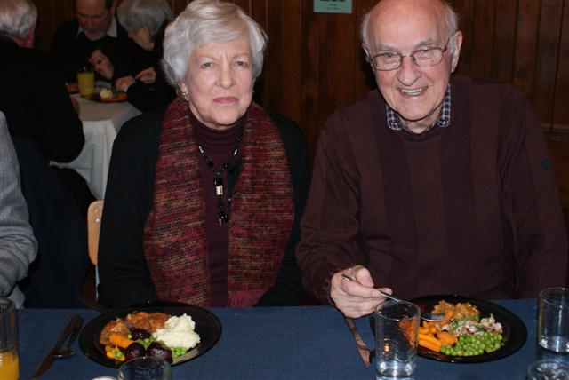

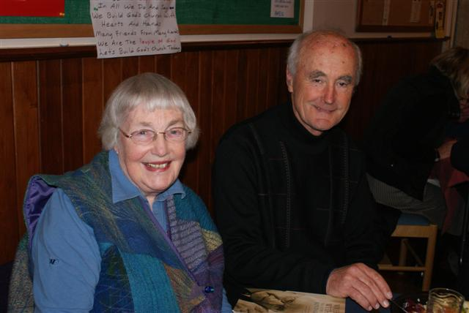

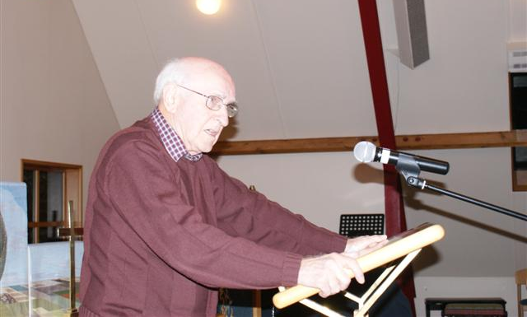
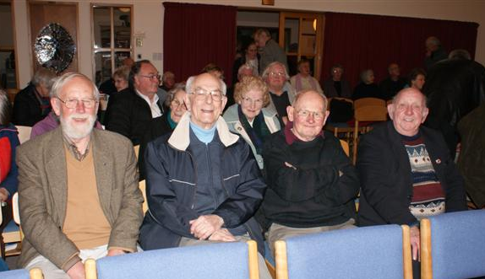

CONNECTIONS

It is one of the oldest dictums of warfare, attributed to Sophocles, that “no one loves the messenger who brings bad news.” Despite this, it was integral to the code of honour by which combatant forces communicated, that the messenger was not to blame for the message he carried, and was entitled to safe passage. However ferocious the hostilities, and however deeply felt the animosities between the warring parties, honour was honour, and to shoot the messenger because you did not like the message was a dishonourable thing to do.

Many variations of the same dictum have emerged since, but they all amount to an equally ancient device, argumentum ad hominem - literally “argument against the man” - employed by those whose argument is thin. It is to respond to an argument by attacking or appealing to a characteristic of the person rather than by addressing the substance of his argument. The task of proving or disproving an opponent's argument is thereby deflected, “on to the man.” We've all tried it, with greater or lesser success - much lesser in the case of those occasional domestics!

And that is exactly the tactic employed against Chief Justice Sian Elias this last week when, greatly daring, she broke with the convention of strict judicial silence/neutrality on things “political” and spoke from her heart and her experience on a raft of sensitive issues confronting her profession on a daily basis - issues relating to the crime rate, punishment, imprisonment, rehabilitation. As it happened, and no surprise at all, none of her observations were perceived to be complimentary to the current tough punitive policies filling our prisons to bursting point..

Enraged, Minister of Justice Simon Power, who surely knew very well the Chief Justice spoke only the truth, the whole truth, and nothing but the truth about the seriously flawed policies of successive governments, his own included, took the ad hominum escape route. It's for the parliament to make the law, he blustered, it's for the judiciary to interpret it; I'm the Minister, she's the Chief Justice; she should do her job, I'll do mine - or words to that effect. And others climbed in behind him, notably his allies in Act, and predictably, the Sensible Sentencing Trust adding a demand for Dame Sian's immediate resignation.

Despite the prediction of several commentators that the outspoken Justice has this time crossed a bridge too far and will be gone by Christmas, there is behind the dust storm a huge community of opinion that Dame Sian having bravely spoken the truth any responsible government should heed, will stand her ground.

So what has been said that has caused such outrage in the corridors of power? Well, no more than what an endless succession of well informed researchers and reformers have been saying for decades . . . .

  - that successive governments under public pressure have shied away from expert advice advocating rehabilitation programmes and increased community sentences, to the more punitive prison-based regime demanded by public opinion

  - despite this the crime rate has blown out, and as a logical consequence the prison population has increased dramatically.
(New Zealand has more people in prison per head of population than any comparable western country except the United States, and Judge Elias estimates that under current policy and law will blow out by 35% in the next eight years)

  - past good attempts to reform the system have been prejudiced by headline-grabbing media intent on personalising and politicising justice issues, and fueling the public appetite for tougher sentences. Judicial policy should be above these pressures, and not subject to them.

  - the current fashion for making the victim the centre of attention in court cases is damaging the right to a fair trial, and even worse, is harming victims emotionally.

(Most outrageous of all to Mr Power and his colleagues, but never more than a whimsical idea in the speech by the Chief Justice, was the notion of an amnesty for selected prisoners, in religious terms a 'jubilee', if not as an act of mercy, then as a preferable alternative to building further zillion dollar prisons.)

The Minister of Justice has been preparing for his present office for the nine years of the Labour Government. He is highly rated for his grasp of the issues relating to his most sensitive portfolio. He has a very good idea of what is working, and what is not, in justice and corrections. All the more reason why he should step back from the vapour of indignation with which he now chooses to enshroud himself, and face the force of the challenge mounted against his failing policies. In this case the Chief Justice is both the message and messenger. He may shoot the messenger, figuratively speaking, but the integrity of the message is unassailable and must not for much longer be ignored.

Dame Sian Elias is no left-wing hand-wringer. Her proposals are not radical, or even new.. She has been a lawyer for 40 years. She's the country's first female QC. She's spent 10 years as Chief Judge and enjoys the confidence of her peers. She's eminently well read, and hugely experienced. It is hard to imagine anyone more qualified to tell us what's wrong with the justice system and why it is failing so badly. So let the law-makers abandon their refuge behind the niceties of outworn conventions and recognise the truth of an issue that vexes us all. There is more at stake than hurt feelings or offended protocols.

Ken Russell

