Dunedin Methodist Parish
Finding good in everyone Finding God in everyone



Presbyters: | Rev. Stuart & Rev. Cornelia Grant | 453 6762
Parish Stewards: | Mr Neil Thompson | 489 5078
 | Dr Richard Cannon | 464 0564
 | Mrs Fay Richardson | 489 5485
Tongan Steward: | Mr Palanite Taungapeau | 456 3144
Parish Office: | Stuart: parish@dmm.org.nz  Cornelia: scch.grant@xtra.co.nz  Sarah: sarahc@dmm.org.nz | 466 4600

We are at home on website http://www.dunedinmethodist.org.nz

PARISH BULLETIN
15th NOVEMBER 2009

WORSHIP FOR SUNDAY 22nd NOVEMBER 2009
9.30am |  | Mornington | S Grant
9.30 am |  | Mosgiel | E Merrett
11.00 am |  | Glenaven | S Grant
11.00 am |  | Wesley | E Merrett
1.00pm |  | St Kilda | N Taungapeau
6.00pm |  | Broad Bay | No Service


RAINBOW READINGS: BROAD BAY
You are invited to drop in today for a programme of poems, stories and reflections on diversity: 6-7pm at Broad Bay Methodist Church in Greig Street, just off Portobello Road. Bring (or wear) something of your favourite colour, and some food to share afterwards with tea or coffee.

GLENAVEN CHURCH will hold their annual meeting in the course of their worship following a shortened service on Sunday 22 November.

PARISH COUNCIL meets on Wednesday, 18 November, 7.30pm at Mosgiel.

MOSGIEL PEOPLE – HOUR OF PRAYER ON THE TAIERI
The Taieri Ministers Association invites all congregations to gather and pray for one hour, -
Where? At the Catholic Church.
When? Saturday, 28 November, from 9.30 to 10.30am
Followed by morning tea.

CHORISTERS CONCERT
The Choristers present an afternoon tea concert with guest artists at Mornington Presbyterian Community Centre, Maryhill Terrace. Sunday 22nd November at 2.00pm. Admission $8.00.

JUMBLE SALE
The Mission will be holding a Jumble Sale at Wesley Hall on Saturday 27th February 2010, with all proceeds going towards WesleyVillage.
Any items you would like to donation would be extremely appreciated, please phone Sarah on 4664600 to arrange collection, or these can be delivered to Wesley House.
All items welcome – nothing too large or too small!
Nearer the time any preserves, jams or baking would also be welcome.

GREETING FROM ALAN UPSON
A greeting was sent from the Mornington Leaders Meeting to Rev Alan Upson before his induction as President of Conference. In his reply he said:
“Thank you for your lovely greeting and for remembering me. I loved being with you people gathered at the Mornington Church and the others in the parish. I never thought I'd end up as President. But I'm glad. I'll give it my best and I'll enjoy it. I've the support of all you loving people and believe that God is to blame and can sort me out when I need it. Grace and peace to you all. Alan.”

THANK YOU TO Y@M FOR ANOTHER FINE SERVICE
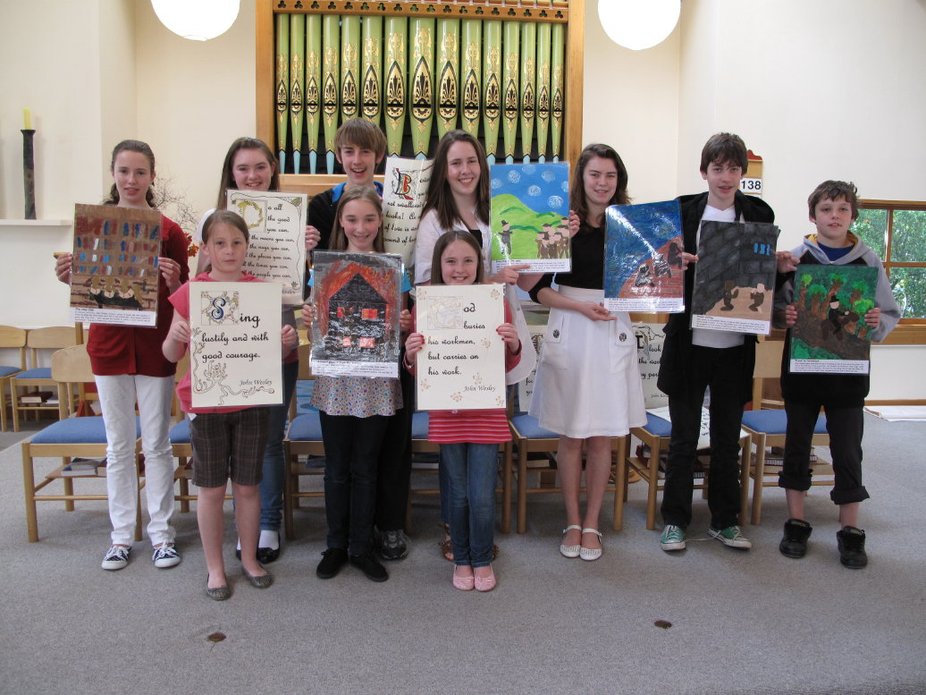
John Wesley – those who attended last week’s service at Mornington, led by Ginny Kitchingman and the Y@M group, now have a greater understanding of the man who was John Wesley: his fiery enthusiasm, and his failings, his concern for the poor, his drive and perseverance in adversity. Episodes from his life were illustrated with collage pictures, and his words with illuminated texts: “Sing lustily” “Do all the good you can, by all the means you can, in all the ways you can …” “I look on all the world as my parish”. Thanks to all the Y@M members who presented an excellent service so competently, and to Ginny. George Davis delivered a short address setting John Wesley in the context of the 18th century, which was much appreciated, and is reproduced in this bulletin as the Connections article.

Photos of the Y@M collages and illustrations can be seen on the Parish website (http://www.dunedinmethodist.org.nz) in the 'Recent Photos', or 'Youth matters' photo galleries.

METHODIST CONFERENCE:
The annual church conference met at Christchurch, commencing on Saturday 7 November, when the Rev. Alan Upson was inducted as President, and Ms. Lana Lazarus as Vice- President. In next week’s bulletin we will include some of the highlights of the Conference. It will have to wait until then, as the usual summary was not available before the Conference finished, due to some technical hitch. However, we will include information about some important 50th ANNIVERSARIES.
One of the first items on the agenda of the Methodist Conference held at Christchurch last week was an acknowledgement of the 50th Anniversary of ordination of the Revs. Evan Lewis and Ken Russell, both members and former ministers here at Mornington. We offer them both our hearty congratulations. Ken continues in supply ministry at Blenheim, and Evan is convenor of the Explorers’ Group here at Mornington.
Another very significant occasion was the celebration at the Conference of the 50th anniversary of the ordination of women in New Zealand. The Methodist Church ordained Phyllis Guthardt (the Rev. Dr Dame Phyllis, to give her her full title) in 1959. She was honoured last Monday morning in a special service by the full Conference, with an address being given by the Anglican Bishop of Christchurch, Dr. Victoria Matthews. We sang a hymn specially written and composed for the occasion by Colin Gibson. Prior to this, on the Saturday evening, Phyllis was also honoured by a group of mostly women presbyters. A video was taken of the Conference event, and it would be possible to screen this on some suitable occasion in the near future.
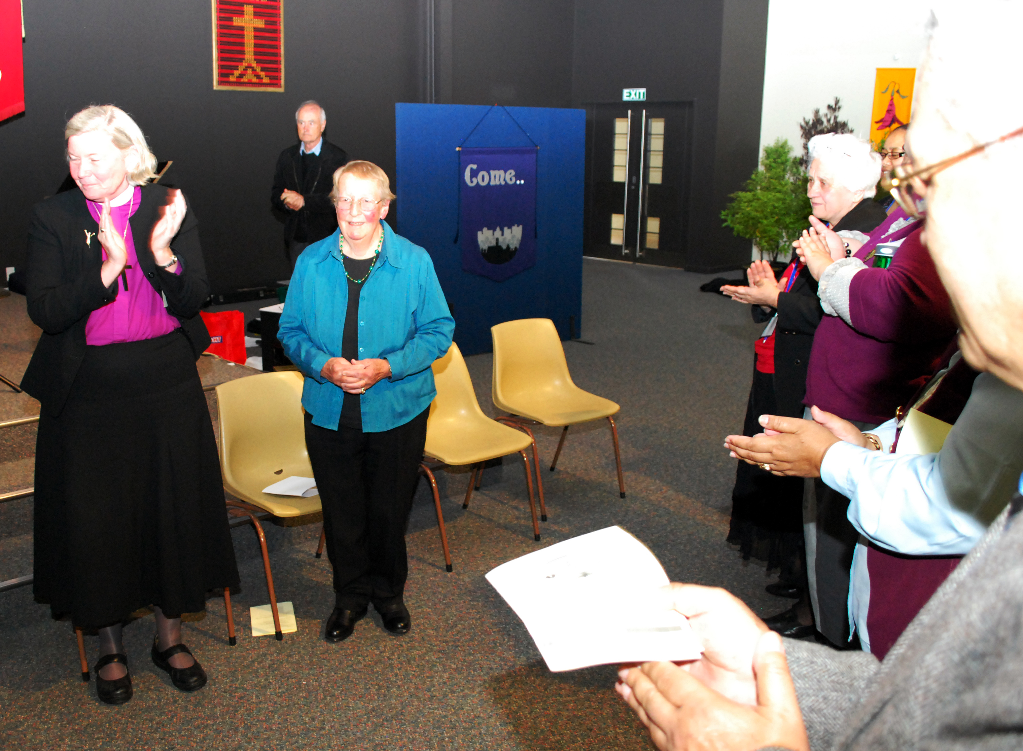

Dr Phyllis Guthardt being honoured by the Conference

BLUFF CO-OPERATING PARISH is the southernmost Parish in the South Island. It is a three-way (Anglican – Methodist – Presbyterian) cooperating venture, worshipping in the former Methodist church building. They are celebrating the 50th anniversary of the building today, and Stuart has travelled there as Synod Superintendent to preach at the service.



John Wesley, and the Holy Club, in the context of the 1700s – and today.

Thank you, George, for allowing your address given at the Y@M service at Mornington last week to be used as the Connections article.

John Wesley is the founder-figure of the Methodist Church. Its unitary or connexion structure and fundamental attitudes derive from his teachings and practices. He was a child of the early 18th century – an era unfamiliar to most of us. It was an early British colonial age involving populating America and subduing India, an age of unsettled religion, pre-democratic, and with increasing urbanisation, and trade based on often foolish financial investments. John Wesley was a child of privilege – his father , Rev Samuel Wesley was an orthodox Anglican priest, who wished his son John to follow him in the profession, but his mother Susanna, was the daughter of a famous non-conformist preacher, Rev Samuel Annesley. There were tensions in the household: a headstrong independent Susanna and her conservative husband, Samuel however, whose own Westley family also came from a line of non-conformist preachers.

Why did this promising young student help found a university group called the “Holy Club” which practised a vigorous religious discipline combined with a strong sense of social purpose? Well, young people feel things deeply and Wesley was no exception. His was a life that had purpose branded on it. As he grew up he saw a world of inequalities, a world far distanced from the Christian ideal of sharing, loving and honouring Gospel teachings. He saw slavery and servitude growing in England and worse, being increasingly exported to America. He saw people sheltering in ditches and hedgerows who had lost their homes in the countryside as a result of enclosures of small farms by the rich and the growing middle class; he saw women turning to prostitution in order to provide for families, or to satisfy their need for the new drug of choice – gin; he saw chaos in the social order at a time when the traditional parish-based church seemed less effective; and he saw governments run by the privileged for their own ends with no thought for the poor who were loosely described as sturdy beggars and leeches on the parish. It was a time before public sanitation as we know it, and life expectancy was 35 not 70. Life was, as the philosopher Thomas Hobbes stated, “poor, nasty, brutish and short.” Roads were terrorised by robbers or “highwaymen” and cities and towns by roving mobs in this pre-police age. It was a brutal time of brothels and public houses, betting on cock-and dog fighting, bare-knuckle fighting. Most people rented poor premises as very few people owned their home. The few rich were conspicuously wealthy in relation to the multitude of the poor. Less than 5% of the population was able to read and write. All of these social evils pushed a young John Wesley to take action.

In 1729, aged 26, John Wesley became a university tutor in Lincoln College, Oxford and joined the Holy Club. This group met three or four evenings a week and read the classics of literature together, prayed, kept personal diaries, and engaged in “charitable employments.” The last included visiting the sick and those in prison – these activities were widely censured by the authorities. The group gained nicknames: ‘Methodists, Enthusiasts, Bible Moths, Bible bigots, Sacramentarians. The group petitioned (wrote letters to the authorities) on behalf of prisoners, looked after children destitute after the imprisonment of their parents, secured legal advice for prisoners, advanced them money, and taught the children of the poor to read and write. The criticism of the activities of the group speaks volumes about the cynical state of society.

What led Wesley 10 years later in 1739 to take up a life in service of the poor and with the poor? “Expediency” to use his term. It was the only, the necessary and the vital thing to do. Some traditional parishes refused to allow him to preach. Consequently, Wesley had to take his message to where people would listen. As well, personally, he felt he had “an extraordinary call” to be an itinerant preacher. In this matter he was following well-trodden steps previously experienced by early Roman Catholic monks and the Lollards who attempted to place the English translation of the Bible before the people.

What was his message? Wesley felt ‘A Methodist was one who has the love of God in their heart, who loved God with heart and soul, and with all their mind, and with all strength, and who was therefore, happy in God.’ His was a teaching role where repetition was effective. Wesley offered the people a choice. You could choose to be a Christian because God’s Grace is offered freely to all. It is still an eternal choice waiting to be accepted. To the poor of the eighteenth century the offer of Grace was indeed appealing.

What has changed? We don’t have poor in ditches, but under bridges and in drop-in centres; we don’t have widespread slavery but we do have immigrant labourers and shop workers working for poor wages; prostitution is still with us, and gin has been replaced with “ice”, cocaine, marijuana, party shots, and readily available alcohols. Highwaymen have been replaced by bikie gangs, and while the literacy rate might now be 95% the divide between the poor and the conspicuously rich is increasing in New Zealand and the rest of the western world. We need Wesley here today as much as ever.

Essential reading: James Stuart, The John Wesley Code: Finding a Faith that Matters, Philip Garside Publishing Ltd, Wellington 2008.
George Davis

Giggle Corner:

LOT’S WIFE
The Sunday School teacher was describing how Lot’s wife looked back and turned into a pillar of salt, when little Jason interrupted, ‘My Mummy looked back once while she was driving’, he announced triumphantly, ‘and she turned into a telephone pole!’

GOOD SAMARITAN
A Sunday School teacher was telling her class the story of the Good Samaritan. She asked the class, ‘If you saw a person lying on the roadside, all wounded and bleeding, what would you do?’
A thoughtful little girl broke the hushed silence, ‘I think I’d throw up’.

UNANSWERED PRAYER
The preacher’s 5 year old daughter noticed that her father always paused and bowed his head for a moment before starting his sermon. One day, she asked him why. ‘Well, Honey,’ he began, proud that his daughter was so observant of his messages.
‘I’m asking the Lord to help me preach a good sermon’.
‘How come He doesn’t answer it?’ she asked.

SAY A PRAYER
Little Johnny and his family were having Sunday dinner at his Grandmother’s house. Everyone was seated around the table as the food was being served. When Little Johnny received his plate, he started eating right away. ‘Johnny! Please wait until we say our prayer,’ said his mother. ‘I don’t need to’ the boy replied. ‘Of course, you do’, his mother insisted. ‘We always say a prayer before eating at our house’. ‘That’s at our house,’ Johnny explained. ‘But this is Grandma’s house and she knows how to cook!’

