Dunedin Methodist Parish
Finding good in everyone Finding God in everyone



Presbyters: | Rev. Stuart & Rev. Cornelia Grant | 453 6762
Parish Stewards: | Mr Neil Thompson | 489 5078
 | Dr Richard Cannon | 464 0564
 | Mrs Fay Richardson | 489 5485
Tongan Steward: | Mr Palanite Taungapeau | 456 3144
Parish Office: | Stuart: parish@dmm.org.nz  Cornelia: scch.grant@xtra.co.nz  Sarah: sarahc@dmm.org.nz | 466 4600

We are at home on website http://www.dunedinmethodist.org.nz

PARISH BULLETIN
22nd NOVEMBER 2009

WORSHIP FOR SUNDAY 29th NOVEMBER 2009
9.30am |  | Mornington | S Grant
9.30 am |  | Mosgiel | C Grant
11.00 am |  | Glenaven | S Grant
11.00 am |  | Wesley | C Grant
1.00pm |  | St Kilda | P Taungapeau
6.00pm |  | Broad Bay | No Service

MOSGIEL PEOPLE – HOUR OF PRAYER ON THE TAIERI
The Taieri Ministers Association invites all congregations to gather and pray for one hour, -
Where? At the Catholic Church.
When? Saturday, 28 November, from 9.30 to 10.30am
Followed by morning tea.

CHORISTERS CONCERT
The Choristers present an afternoon tea concert with guest artists at Mornington Presbyterian Community Centre, Maryhill Terrace. Today at 2.00pm. Admission $8.00.

JUMBLE SALE
The Mission will be holding a Jumble Sale at Wesley Hall on Saturday 27th February 2010, with all proceeds going towards Wesley Village.
Any items you would like to donate would be extremely appreciated, please phone Sarah on 4664600 to arrange collection, or these can be delivered to Wesley House.
All items welcome – nothing too large or too small!
Nearer the time any preserves, jams or baking would also be welcome.

HOPE IS OUR SONG
On Sunday evening, December 6th, at Knox Presbyterian Church, commencing at 5.30pm, there will take place the Dunedin launch of the new New Zealand hymnbook Hope is our Song, starting with a pot luck meal, followed by a celebration and service with plenty of singing.
This will be your chance to meet Shirley Murray, Colin Gibson, Cecily Sheehy, Marnie Barrell, Marion Kitchingman and many more of the hymn-writers whose music and words have inspired and uplifted us. Copies of the book will be on sale at $30, and you can get yours autographed on the spot. The University of Otago will have awarded Shirley an honorary doctorate on the previous day, in recognition of her remarkable contribution to world hymnody, so we will have the opportunity to honour her again at this book launch. A not to be missed celebration.

HAPPY BIRTHDAY:
To Oliver Devereux who celebrates a Birthday today.

MORNINGTON LEADERS’ MEETING
The last meeting for the year takes place on Tuesday, 1 December, 7.30pm

WESLEY REMINDER!! On Sunday 29th November (1st Advent) we shall have morning tea before the service at 10.30.

FROM THE PARISH COUNCIL MEETING
The Parish Council Meeting last Wednesday received a report on the Ministry Review that was held on early October. Copies are being made available to all Leaders’ Meeting members so that you will be well informed on the findings of the review. In the New Year, we will use the review as a basis of working out the parish’s ministry needs for the future. If you don’t already have a copy of the report, please pick up a copy at church today.

FROM THE METHODIST CONFERENCE
A DVD of various presentations and papers given at the Conference is available. It includes a video of the celebration of the 50th anniversary of the ordination of women, which could be screened in people’s homes, or at Mornington church. We’ll make arrangements for this over the next week or two.
Another outstanding presentation at the conference was by Dr. Jim Stuart, who presented a paper entitled “An Uncommon Train of Providence”.
If anyone would like a copy of this, please get in touch with Stuart Grant.
The idea of “Providence” sound rather old fashioned to us in the 21st Century, but, as Jim Stuart argues, it played a very significant part in John Wesley’s life as his ministry and the Methodist movement developed. Jim draws parallels with his own life and faith journey and invites us to do the same. Here are some conclusions that Jim draws:

Following in the way of Providence teaches a number of truths about how we can understand the presence of God. Let me list five for now. I am sure you can add more.

- The way of Providence teaches us that God’s presence surprises us. God moves among us in ways we often never anticipate – an unexpected encounter, a personal disappointment, a closed door, an unplanned event. We spend most of our time in Conference gatherings like this trying to reduce God to reports, trying to tame God through planning and process, trying to contain God with our institutional agendas and bureaucratic processes.

- The Way of Providence teaches us that God works in what Wesley called ‘extraordinary’ ways often in spite of and contrary to the works of the church. As Wesley once observed, ‘My ordinary call is ordination by the bishops… my extraordinary call is witnessed by the works of God.’ When we understand this paradox, then Wesley’s well-known aphorism, ‘I look upon the whole world as my parish,’ takes on new meanings.

- The Way of Providence teaches us that there are no accidents in life, that in the words of Paul, ‘all things work together for good for those who love God, who are called according to God’s purpose. (Rom 8:28). It has taken me almost a lifetime to begin to understand in a small way what Paul meant. Again and again Wesley learned this truth, sometimes the hard way.

- The Way of Providence teaches us that we can’t package God, that is, shape God into our image, make God do our bidding, fit our theological paradigms. As E Stanley Jones, Methodist missionary to India, once observed, ‘There comes inevitably those times in our lives when we have to let go and let God.’ It is often said that Wesley set out ‘to redeem a whole nation’ – but that is a romantic myth – Wesley only sought to follow the way of Providence as it opened before him.

- The Way of Providence teaches us that we discover the guiding presence of God not only in the expected places such as church services, special buildings, intimate prayer groups, important service projects but in the cracks and unexpected places where the light is trying to break through. The eyes of a child, a healing words of a friend at a time of loss, the courageous journey of a someone struggling with an illness such as cancer, the pain of rejection, the multitude of moments in life when we don’t know what path to take and we are forced to open ourselves to whatever is to come believing that somehow, in some way, hidden to us, God will be present guiding and embracing us.

I am sure you can add more.



Hands of 500 Offering

Hi Jo

After my piece last month on the Offering as “all part of the service”, let me tell you this time about another offering we sometimes have at Mornington. We call it “Hands of 500”, because it’s in the hands of individuals to offer something of themselves up to a limit of 500 words. So far 18 of us, a fair cross section of the congregation, have had a go. Here are some of the things people have said, grouped under themes that seem to have emerged. Actual wording used is in italics.

The presence of the past
- One member’s contribution was entirely about the legacies left by members who are no longer with us. She gave three examples of many riches that have become part of us.
- All but two of the other contributors touched on their early life to at least set the scene for their reflection.
Parish support
- Half of the contributors chose to acknowledge the importance of the congregation to them.
- I must thank this Church family for allowing me to be who I am in a way I’ve never experienced anywhere else. This is a safe place, intellectually and spiritually robust but inclusive and supportive.
- I perhaps would not be anywhere else if not here.
- Here both strands of a healthy church community exist – the mutually supportive society and the range of theological thought.
- The comfort I got when I came on a Sunday and could quietly reflect and put things into perspective was invaluable to my sanity.
The power of music
- One member talked solely of my musical journey through singing. My first effort in singing was aged three, standing alongside my father on the pew.
- For me – as for so many others – music is the Divine – God. “The voice of the pipes is the song of God”.
- Over half the speakers named at least one piece of influential sacred music, including early childhood hymns.
- Three of the speakers became singers or performers at the end of their offering.
Personal prayer
- A third made reference to prayer. One contribution was titled, a simple statement of faith and prayer, and the women who have influenced me, leading to communing with God naturally.
- My first response to most situations is prayer – it is my dialogue with God.
- Prayer? Yes – as centering, quietness, no guilt, embracing all of my selves.
- “Namaste” or “Praying hands” in association with the experiences of the senses is my story.
- Two speakers noted their own recoil at times in their lives when others had proffered them healing prayer.
The planet
- One speaker broke any imaginary mould by speaking of Australia through the eyes of a New Zealander, including the large-scale works of art matching the size of the country. When you return home, you realise that...it’s not the red earth that moves us, but the green fields, maybe, our lakes, and the snowy Alps. But our countries are neighbours. We are family.
- Where is the better world?... Taking care of this earth. A world for all... Simple, yet so hard to achieve.
- “The life force of creation/Is there in earth and stone.../Flesh and bone”.
Plain and practical
- Dad taught me that there is a loving way to shut a door.
- Choosing and posting a birthday card to each child for his/her special day is both a privilege and a pleasure.
- My faith strong, uncluttered and simple, and my answer to “How do I know?” is that of a five-year-old pupil of mine who, when asked how she knew 3 + 2 = 5, replied firmly “I just know”.
- I live my faith quietly and everyday, I don’t shout it from the rooftops or try to bring it into conversations.
Pilgrimage and perplexities
- During my Bible Class years I rebelled and 14 years later it was a drunk woman who showed me the way back.
- I no longer believe some of the teachings about Christ. I no longer believe that Christianity has an exclusive grasp of the truth.
- I am in the process of still trying to work out for myself whether I am a Christian or not as Easter has always been a problem to me.
- God might be our human subjective creation, maybe an impersonal ground rather than a Divine person intervening in our lives.
Positive pointers
- That which is “more than I am myself” is my experience of Church.
- Society needs...a strong and respected voice to espouse all that is fair and reasonable, and...a more progressive theological element may contribute to that outcome.
- The essential awareness of God, energy, life force, spirit, within and without, indescribable, bounteous and beautiful, has always been there for me.
- All humans seek God; just different cultures might have different names for him.
- An important taonga for me is our Maori language. I have friends from several faith traditions. Now I believe there is one Great Spirit.
- It seems that, in some part of my being, there is a God space...maybe a “Soul space”. For me, the mystery that is “soul”, like the mystery of God, continues. It’s my prayer that when my time comes...I will be able to say “It is WELL, It IS well with my soul”.
- It suddenly occurred to me what resurrection meant for me – that we had been through deep dark harrowing times but in the end we had come through it, perhaps not the way I had envisaged but I had survived, reasonably intact.
- I believe the Christian life has a key which provides spiritual uplift without which our lives have little meaning.
- My faith, such as it is, helps me to live as well as I can, and motivates me to do what I can to help others.

David Kitchingman, with thanks to Bev, Rachael, John, Nigel, Robyn, Dale, David P, Joan R, Joan W, George, Liz, Hilda, Alan, Neil, Jeanette, Aelred, and Trish

CONFERENCE SUMMARY arrived after this bulletin had been prepared. Some copies are available this morning, and more can be made available if necessary.
If you have e-mail, Stuart can send it to you.

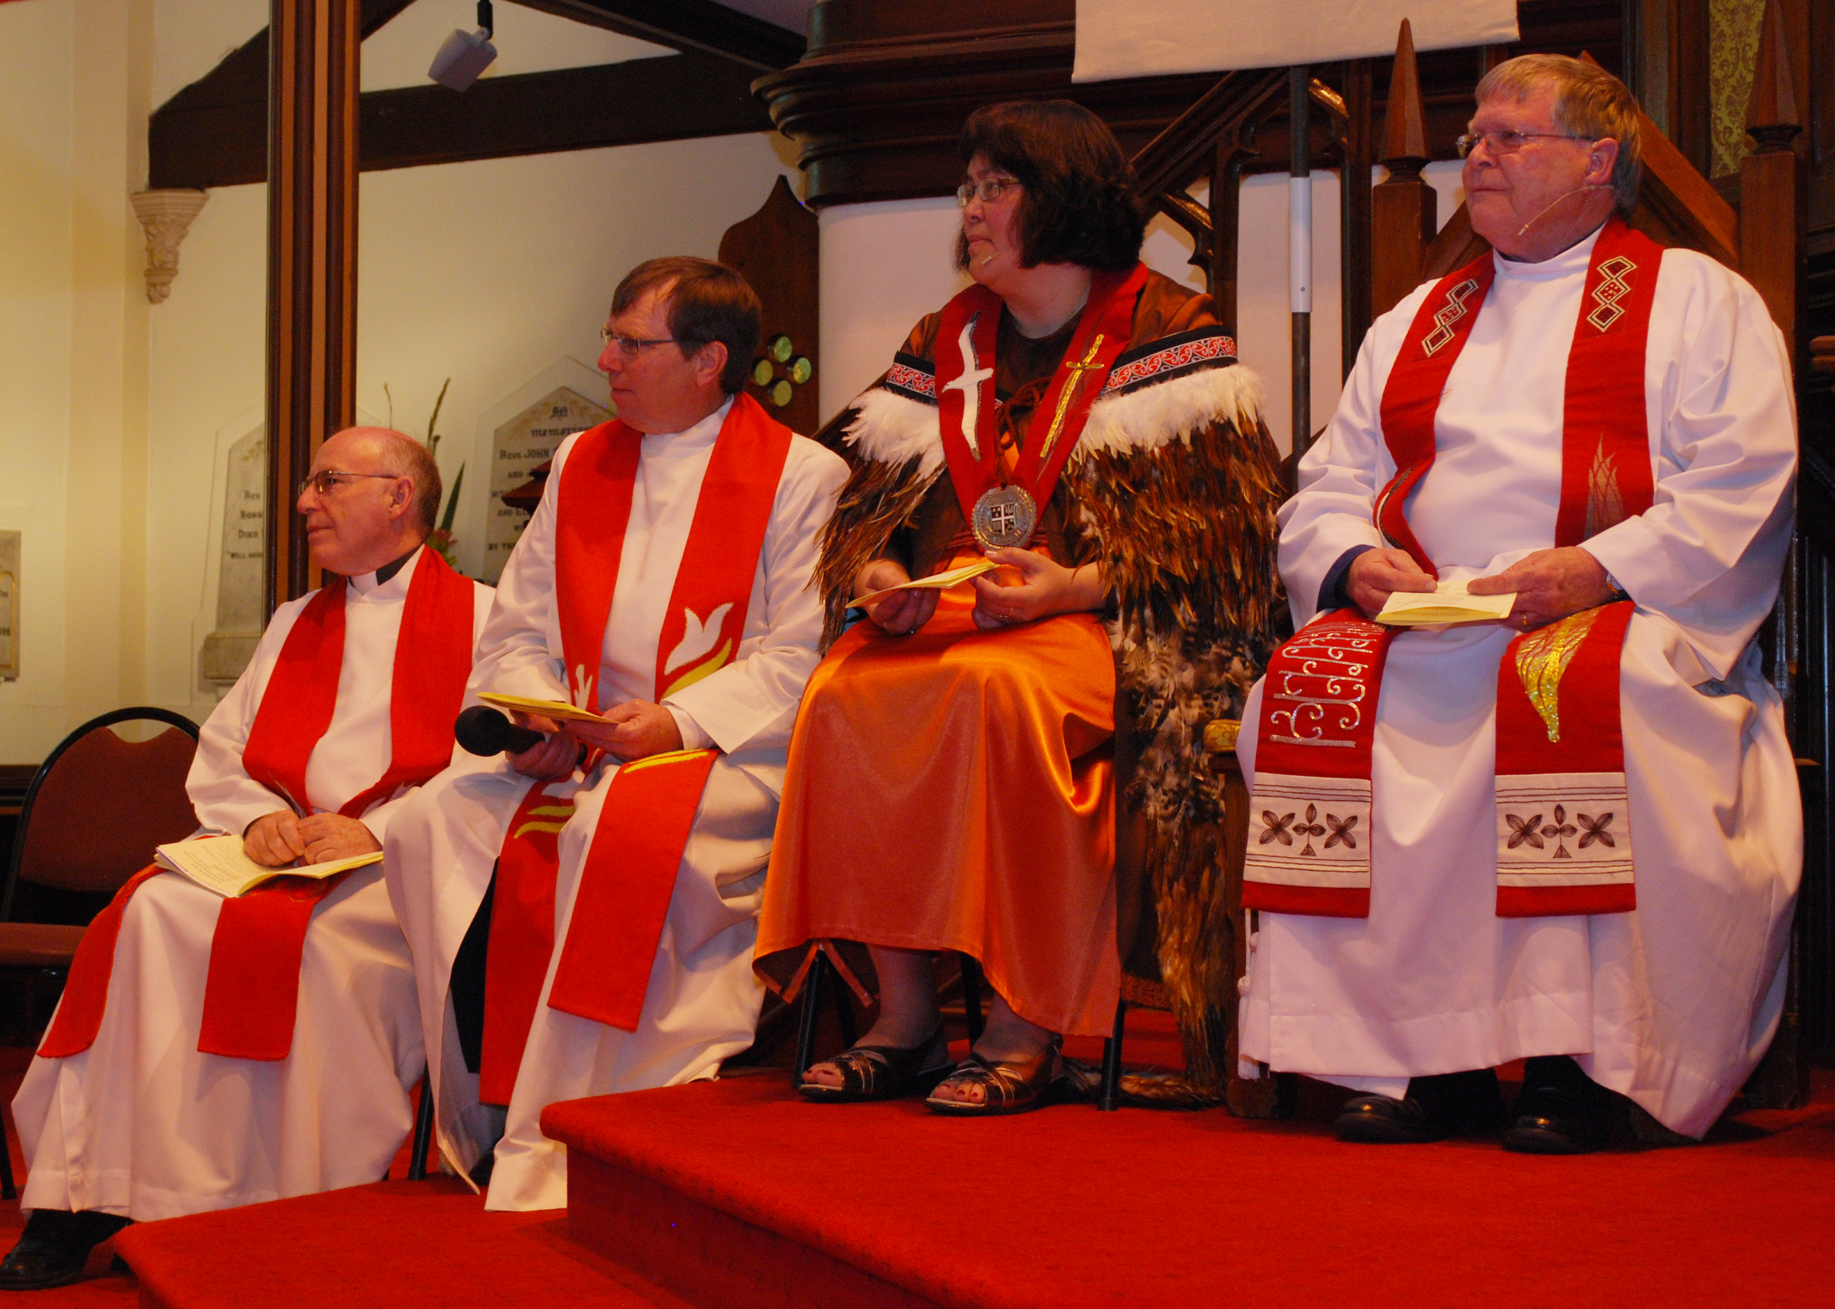

The President of the Methodist Church for 2009 – 10, the Rev. Alan Upson, and the Vice – President, Lana Lazarus.
On the left of the picture are the Rev. Terry Wall, President’s chaplain, and the Rev David Bush, General Secretary.

