Dunedin Methodist Parish
Finding good in everyone Finding God in everyone


Presbyters: | Rev. Stuart & Rev. Cornelia Grant | 453 6762
Parish Stewards: | Mr Neil Thompson | 489 5078
 | Dr Richard Cannon | 464 0564
 | Mrs Fay Richardson | 489 5485
Tongan Steward: | Mr Palanite Taungapeau | 456 3144
Parish Office: | Stuart: parish@dmm.org.nz  Cornelia: scch.grant@xtra.co.nz  Sarah: sarahc@dmm.org.nz | 466 4600

We are at home on website http://www.dunedinmethodist.org.nz
PARISH BULLETIN
20th DECEMBER 2009

WORSHIP FOR SUNDAY 27th DECEMBER 2009
9.30am |  | Mornington | S Grant
9.30 am |  | Mosgiel | C Grant
11.00 am |  | Glenaven | S Grant
11.00 am |  | Wesley | C Grant
1.00pm |  | St Kilda | A Finau
6.00pm |  | Broad Bay | S Grant

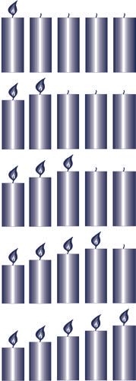
Advent Four – Love
With even a small level of training anyone, at any age, can improve their life. CWS partner Developers Foundation in the Philippines trains poor rural residents in pig raising, enabling them to earn more money for investment in other money-making ventures. It also enables them to employ others. With determination and help from Developers Foundation, a better life is possible. Please give the people of the Philippines a chance by supporting the CWS Christmas Appeal 2009.

NEXT BULLETIN
This is the last bulletin for 2009. The first one in the New Year will be available on Sunday, 31 January

MORNINGTON CHURCHES CAROL SERVICE
Today, 7pm in the Presbyterian Church Centre, 16 Maryhill Terrace, with supper to follow.

WESLEY
Combined Caversham Churches Christmas service at Wesley Church, Tuesday 22 December, 7pm. There will be supper to follow. Please keep this date free!

MOSGIEL NOTICES
Carol Singing, late night shopping, Tuesday Dec. 22. Recruitment of singers, adult and children, is under way. Commitment involves about 20min of carols on the night, with a practice session on Saturday, 19 Dec. Please advise John Stoddart, 489 6308 ext 720 with contact details of choir persons.

CHRISTMAS EVE WORSHIP AT GLENAVEN
Christmas Eve Worship for the whole parish will be held at Glenaven Church, Chambers Street, North East Valley, at 11.15pm next Thursday.
Come along at 10.30 and gather with the other worshippers for a pot-luck supper and a time of fellowship beforehand, and bring your friends, neighbours and visitors. Everyone is warmly welcome.
Christmas Day – Mosgiel 9.00am, Mornington 9.30.

HAPPY BIRTHDAY:
To the following children celebrating birthday’s over the Christmas break:
- 6th January – Christopher Gray
- 9th January – Simmone Sarup
- 15th January – Lilly Kopi
- 25th January – Nicholas Elkins

KNOX 150TH ANNIVERSARY
Knox Presbyterian Church will be celebrating their 150th anniversary at Queen’s Birthday weekend, 4-6 June 2010.
All former parishioners and others are invited to join in the celebrations. For further information, please contact the 150th Anniversary Committee at by post at Knox Church, 449 George Street, Dunedin, phone 03 – 477 0229, or e-mail knox.church@xtra.co.nz

STUDY OPTIONS:
- TRINITY METHODIST THEOLOGICAL COLLEGE is offering a series of intensives in 2010. These are, -Living our Faith: An Ethical Approach; Music and Worship; Creativity, Imagination, and Ministry, - and several others. Please see your church notice boards. The intensives are offered at Auckland, but if anyone wishes to travel, funding may be available. Talk to Stuart.
The intensive, Living our Faith: an Ethical Approach, will be offered at the March School of Theology at Lakelands Park, Queenstown, 21 – 24 March. More about this in the New Year.

- INSTITUTE OF DISTANCE THEOLOGICAL STUDIES (EIDTS)
Have you ever thought you would like to have a deeper understanding of theology, the Hebrew Scriptures, the New Testament, church history and context, ministry studies? EIDTS offers a broad range of study options which you can undertake at home, at your own pace, and in your own time. The courses are NZQA approved. Further information, and a handbook, is available from Stuart or Cornelia.

ADVENT AHOY! It may have been the first time since the Viking raiders a thousand years ago that a church has been overrun by pirates, but that’s what happened at Mornington last Sunday. It wasn’t at all about fear and mayhem, but about finding the treasure of the Christ child at Christmas.
Here are some of the pirates caught in the act.
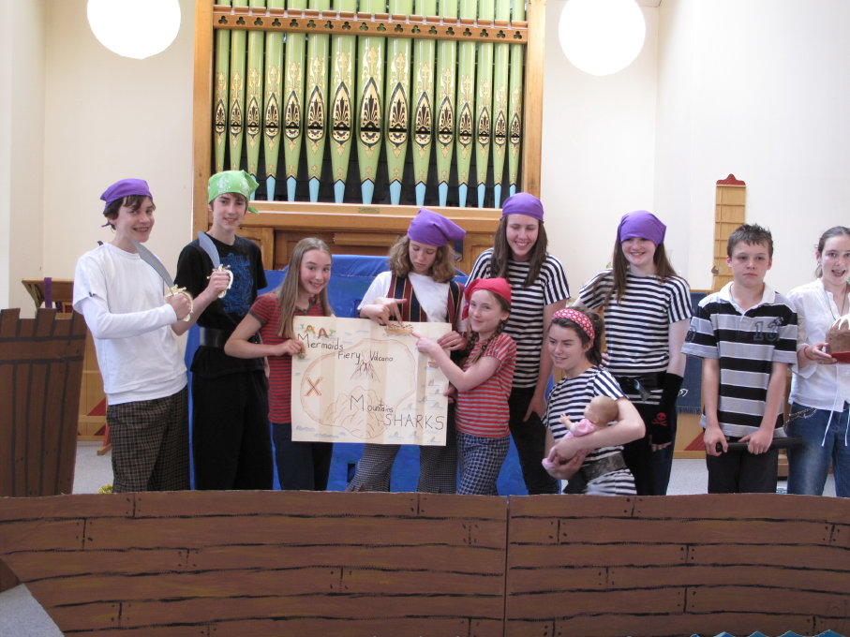

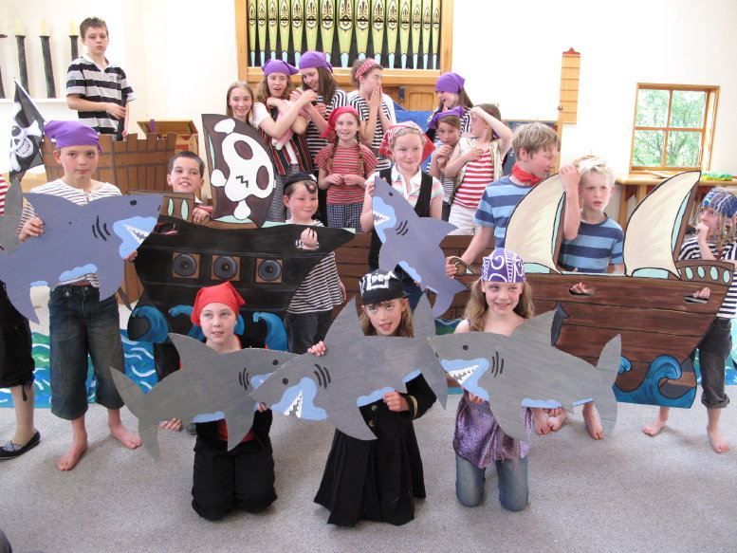

Many thanks to Ginny Kitchingman who brought all her considerable talents to writing and directing the production, - and to all who helped; and of course to the Sunday School and Y@M Group, who enjoyed themselves immensely and gave the congregation a lot of pleasure.


In one of his advent sermons Australian preacher Bruce Prewer links joy and scandal as the twin components in Luke’s nativity stories.

It’s an interesting connection. I suspect we would agree about the ‘joy.’ “Joy to the world, the Lord is come. Let earth receive her King.” Those of us with a theological turn of mind might want to dispute some of the global claims in the 1719 Isaac Watts composition, but God help us if we ever lose the joy of the good news that Jesus is born, the “word made flesh”.

But what about scandal? Scandal is for most of us the very opposite of what we perceive Christian faith to be about. Nobody who covets their good reputation wants scandal. Think Tiger Woods. Until only a few weeks ago Tiger was surely the popular choice for the world’s most perfect human being. The greatest golfer ever. Rich. Charisma. A stunning black man happily married to a gorgeous blond white woman, with two equally beautiful children. The ultimate prize for the world’s most elite enterprises was to enlist the face and imprimatur of Tiger Woods on their products. Yet in a few shorts weeks revelations of infidelity with a remarkable gaggle of call girls and cocktail waitresses, all of them several tiers below the social standing that lovely man had achieved by his own superb excellence, has brought him down. His reputation is in tatters, his marriage under threat, his fans disillusioned, his endorsements falling off, and even his future in golf is in doubt. That’s scandal with a capital S. The world’s media have revelled in the scandal of Tiger. They can’t get enough of it. Evangelical Christians have somewhat smugly consigned him to a richly deserved hell. Others, more rational, have marvelled at the sheer naivety of this avowedly family man, his moral duplicity, his ignorance of the vulnerability of the nature of celebrity, his sheer stupidity. And together we shake our collective heads in righteous agreement. “Aha, the higher they rise, the harder they fall.” For sure.
But that is not the “scandal” to which preacher Prewer refers. The greek word is scandalon meaning literally “a stumbling block” or a “tripping stone.” It’s a key biblical word for what Al Gore has defined as “an inconvenient truth.” Prime examples of the biblical use of the word are typically
“The Lord shall be a sanctuary; but to the houses of Israel a stone of stumbling and a rock of offence.” Is 8: 14
“ We preach Christ crucified, to the Jews a stumbling block, and to the Greeks foolishness.” 1 Cor 1: 23

The concept of scandalon bites deep into a succession of Luke’s insights brought to the preparation for the coming of Jesus - a gift to redeem Israel, but at the same time a stumbling block to bring down the mighty and to turn the established order upside down. In particular, old Simeon’s warning to Mary as the child is brought to dedication. “This child is chosen by God for the destruction and salvation of many in Israel... a sign many people will speak against... and sorrow, like a sharp sword, will break your own heart.”

Here is the not-so-palatable Christmas, the scandalon. Here’s the antidote to the popular notion of a convenient, comfortable, co-operative Jesus all too ready to approve our idolatries and endorse our prejudices. Dare to read between the lines of Isaiah, Luke and Paul this Advent and there it is. This Jesus - better be careful - he’s a joy to the faithful, for sure, but he’s a bump on the road likely to trip the unsuspecting believer and leave him sprawling, Tiger-like, in an ungainly heap of embarrassment or frustration. Believe me, I know it.

The scandalon principle confronts us all, Christian or not. It’s President Obama, would-be Peace President, confronting daily the awful reality of being Commander in Chief and waging two wars. The plaudits of the Nobel Peace Prize resounded in Oslo last week, but has he earned it? Or has he tripped on the stone of an all-too-public hypocrisy that trapped other presidents before him?

It’s the scandalon that looks likely to trip the Copenhagen Conference. Developed nations, with their emission policies largely crafted in their own political interest, token gestures for the Planet, and clearly irritated by the persistence of the developing states for whom the stakes are so much higher. We read their faces. “Would to God the poor sods would see reason, or just go away!” They won’t, and they shouldn’t.

And closer to home it’s the scandalon of the drink/drug culture, sapping the vitality of New Zealanders, a tripping stone to so many of our younger people, getting them into trouble and robbing the potential of so many lives.

Amid the great joy most of us will share on Friday, have a thought for the Marys of our generation, solo mothers, less-than-welcome immigrant mothers, mothers with severely impaired children, mothers caught in a web of poverty. These young women are constantly at risk of scandalon, tripping stones, societal traps at every turn - as was Mary, the mother of Jesus. That she overcame such odds in first century Judea was by the loyal support of her partner, Joseph, and the grace of God. To ensure such miracles of grace in our time and place, is no less a Christmas agenda.
Ken Russell

ARCHBISHOP OF CANTERBURY AT COPENHAGEN
People are so paralysed by fear and selfishness they cannot save the planet, the archbishop of Canterbury said on Sunday during a church service in Copenhagen.
Rowan Williams was preaching in the Danish capital as crucial UN climate change talks entered their second and final week.
He said that fear paralysed individuals, corporations and governments from making the choices needed to affect real and lasting change.
"We are afraid because we don't know how we can survive without the comforts of our existing lifestyle. We are afraid that new policies will be unpopular with a national electorate. We are afraid that younger and more vigorous economies will take advantage of us – or we are afraid that older, historically dominant economies will use the excuse of ecological responsibility to deny us our proper and just development."
But humans were not "doomed to carry on in a downward spiral of the greedy, addictive, loveless behaviour" that had brought mankind to this crisis and he urged people to scrutinise their lifestyles and policies and how these demonstrated care for creation. He called on people to consider what a sustainable and healthy relationship with the world would look like.
His message for conference delegates centred on trusting each other in a world of limited resources. "How shall we build international institutions that make sure that resources get where they are needed – that 'green taxes' will deliver more security for the disadvantaged, that transitions in economic patterns will not weigh most heavily on those least equipped to cope?"


