
Dunedin Methodist Parish
Finding good in everyone Finding God in everyone
www.dunedinmethodist.org.nz

Presbyters: | Rev. Stuart & Rev. Cornelia Grant | 453 6762
Parish Stewards: | Dr George Davis | 453 6540
 | Dr Richard Cannon | 464 0564
 | Mrs Fay Richardson | 489 5485
Tongan Steward: | Mr Palanite Taungapeau | 456 3144
Parish Office: | Stuart: parish@dmm.org.nz  Cornelia: scch.grant@xtra.co.nz  Sarah: sarahc@dmm.org.nz | 466 4600
PARISH BULLETIN
14th March 2010

WORSHIP FOR SUNDAY 21st MARCH 2010
9.30am |  | Mornington | C Gibson
9.30 am |  | Mosgiel | G Watson
11.00 am |  | Glenaven | C Gibson
11.00 am |  | Wesley | G Watson
1.00pm |  | St Kilda | A Finau
6.00pm |  | Broad Bay | C Gibson

CELLISTS OF OTAGO
A cello choir made up of fourteen of Otago’s finest cellists will offer a concert of cello music on Sunday 14 March at 3pm in the Mornington Church. Last year’s concert by this talented and unusual group drew a packed house, and this concert will do so again. The music the cellists and their accompanists will play ranges from classics like Bach, Beethoven, Chopin, Bartok and the great cellist Pablo Casals to arrangements of traditional tunes like Lord of the Dance and the Londonderry Air. A special feature will be new compositions by young Dunedin composer and performer Corwin Newall, whose work has already been played by the New Zealand Symphony Orchestra. But the real highlight will be the playing of the massed cellists: a stunningly beautiful and rich sound. Admission is by programme ($10) and profits will go to the Wesley Village Project—another reason for coming along.

OPEN EDUCATION
The popular Open Education programme returns this month at the usual time (the third Wednesday in the month) and place (Mornington Methodist Church) on Wednesday March 17 at 7.30pm. Richard Egan, former Catholic priest and a Medical School researcher, will be talking about Spirituality in Hospice Care, which is the subject of his doctoral studies. Anyone may attend, and there will be an opportunity for group discussion and a question-answer session. Richard was recently featured in the Star newspaper: he has talked to hospice patients, family members, staff, chaplains and Maori authorities and his findings are intriguing. Don’t miss this one.
As usual, this session will be preceded by a meal commencing at 6pm catered by our top chef, Judy Russell. Bookings are necessary: phone Colin Gibson (453 6662) by Monday 15 March. There is a charge of $15 per head for the meal, and $5 for the Open Education meetings.

A TALK BY COLIN GIBSON
J.S. Bach, life and music for the Church.
Friday 18th March at 7.00pm at Mornington Methodist Church. Admission $5.00. (Repeat presentation by Institute of Registered Music Teachers).


DUNEDIN MUSIC SOCIETY
On Sunday afternoon, 21 March at 2.30pm the Dunedin Musical Society will offer another concert at the Mornington Methodist Church. The programme includes piano duets and songs for baritone, soprano and tenor voices. That popular duo Eli Gray-Smith and Malcolm Gould will return with 5 lively Spanish Dances by Moskowski. Admission $2.

BACH’S ST JOHN PASSION
Celebrate Easter with the City of Dunedin choir and its outstanding soloists in a deeply moving performance of Bach great St John Passion (the story of Christ’s arrest, trial, suffering and death) on Sunday 28 March at 3pm in the Dunedin Town Hall. Ticket prices range from $25 to $40: available at the Regent Theatre or at the Hall on the day.

WANTED
An advocate /friend for a middle-aged disabled woman with a moderate intellectual disability. Mileage and a quarterly honorarium are paid. A flexible, interesting job (about 2 hours a month) for a person with good people skills. Please contact Verity on doak@kol.co.nz or 04 569 2708 in the evening.

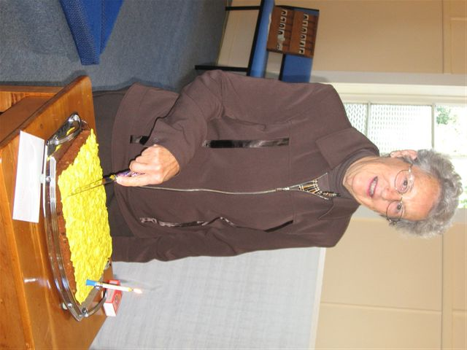

Wendy Thompson celebrating her birthday last Sunday



Which Journey?

On 7 March Rev Don Phillipps preaching in the Mornington Methodist Church led the congregation to confront the role of catastrophe and suffering in the human condition. A key idea was whether God would permit such suffering as we have seen recently in Haiti and Samoa, and as appears to be continuing. Are catastrophes a punishment for evil lives? Are they a trial of fitness to continue the Christian journey? As part of the service hymns and readings seemed to pick up the notion of human life always being on a journey, yet we are in another sense, “home.”

It often seems that in catastrophes there is no rationale. Are writers like the French existentialist Eugene Ionescu correct - there is no God, no God’s plan, no heaven, no hell, just here and now? Life to Ionescu, as in his play, Rhinoceros, was random. That bastion of French order, the fire brigade, became a band of thick-skinned grey rhinoceros rampaging thorough the town. The most rational and philosophic of friends developed headaches, then a lump on the forehead, and became rhinos. The reliable and constant become unreliable and inconstant. Nothing makes sense. In an earlier age Shakespeare’s Macbeth cried out from his trapped conscience that life was ‘a poor player who struts across the stage’ and life was ‘a tale told by an idiot, full of sound and fury, signifying nothing.’ Indeed, all images of catastrophe in a Godless world.

However, the Christian life does have meaning. It has (to use that appalling term) a “roadmap”. Its guide is the life of Christ who gave reassurance of worth and significance for all humanity. So what value do we place on this?

When we prepare for a journey overseas we go to travel agents and seek their advice to plan the trip. Planning aims to avoid catastrophes or at least cope with them if they arise. We establish contacts where we hope to stay and make preparations for the care of things back home while we are away. Banks, electricity, rates, insurance and rental payments are assured and we see that our house is left in order. We care for our health taking appropriate inoculations or carry medicines for areas at risk. Our pets are boarded out or otherwise cared for and kindly neighbours or relatives and friends look after the house. All of this involves planning, time and energy.

If we have faith in the Christian journey of life, as opposed to a Godless or meaningless life, whose advice do we seek, how do we ensure our own safety, when emergencies or catastrophes happen how prepared are we, how do we recognise the significant signposts or sights we hope to see on life’s journey, are we sufficiently physically and mentally prepared, is our spiritual house in order, and what do we expect when we return “home”?
George Davis

