
Dunedin Methodist Parish
Finding good in everyone Finding God in everyone
www.dunedinmethodist.org.nz

Presbyters: | Rev. Stuart & Rev. Cornelia Grant | 453 6762
Parish Stewards: | Dr George Davis | 453 6540
 | Dr Richard Cannon | 464 0564
 | Mrs Fay Richardson | 489 5485
Tongan Steward: | Mr Palanite Taungapeau | 456 3144
Parish Office: | Stuart: parish@dmm.org.nz  Cornelia: scch.grant@xtra.co.nz  Sarah: sarahc@dmm.org.nz | 466 4600
PARISH BULLETIN
21st March 2010

WORSHIP FOR SUNDAY 28th MARCH 2010
9.30am |  | Mornington | S Grant
9.30 am |  | Mosgiel | C Grant
11.00 am |  | Glenaven | S Grant
11.00 am |  | Wesley | C Grant
1.00pm |  | St Kilda | S Ikahihifo
6.00pm |  | Broad Bay | No Service

DUNEDIN MUSIC SOCIETY
This afternoon, 21 March at 2.30pm the Dunedin Musical Society will offer another concert at the Mornington Methodist Church. The programme includes piano duets and songs for baritone, soprano and tenor voices. That popular duo Eli Gray-Smith and Malcolm Gould will return with 5 lively Spanish Dances by Maskowski. Admission $2.0

MUSICAL SOCIETY CONCERT today, Sunday 21st March 2.30pm at Mornington Methodist Church, piano and signing items, cost - $2.00.

OTAGO–SOUTHLAND DISTRICT SYNOD has been meeting this weekend at Lakelands Park, Queenstown. Dunedin Parish is represented by Shirley Parslow (Mornington), Faye Richardson (Mosgiel) together with Stuart and Cornelia Grant as presbyters.
Twenty young Tongan folk from the St. Kilda Church have been there as well, presenting cultural song and dance items, and taking part in a programme with the national Youth Co-ordinator of our church. Te Rito Peyroux.

THE BIBLE WITH ATTITUDE – reminder. The Bible study series continues on Wednesday, 24 March, 7.30pm at Wesley Church

BACH’S ST JOHN PASSION
Celebrate Easter with the City of Dunedin choir and its outstanding soloists in a deeply moving performance of Bach great St John Passion (the story of Christ’s arrest, trial, suffering and death) on Sunday 28 March at 3pm in the Dunedin Town Hall. Ticket prices range from $25 to $40: available at the Regent Theatre or at the Hall on the day.

EXPLORERS GROUP - Meets in the Mornington Church Lounge at 4-30pm on Sunday March 28th. All welcome.
MORNINGTON - MEASURE THE SUNFLOWERS
Due to unforeseen circumstances the date for measuring the sunflowers has been delayed until 28th March.

MORNINGTON LEADERS’ MEETING
The next meeting takes place on Tuesday, 30 March, 7.30pm

MORNINGTON MWF MEETING
Next meeting is on Wednesday 31st March 2p.m. in the Church lounge, hearing about the Life and Times of Eldon Mosley.

FIJI CYCLONE RELIEF
Joeli Vakalala (Wesley Church) featured in the ODT on Wednesday in an article describing his personal initiative to collect clothing, toys etc. for relief in his home island of Vanua Levu. Anyone who would like to help in this initiative may phone Joeli on .
As yet there has been no official request from Christian World Service, but any donations specified for Fiji will certainly be applied to cyclone relief. Address: Christian World Service, PO Box 22652, Christchurch.

HAPPY BIRTHDAY to Amy Jones for 16th March.

OPEN EDUCATION PROGRAMME
Open Education got away to a good start last Wednesday evening with a presentation by Richard Egan on spirituality in hospice care. He shared some of the research on this topic that has been the subject of his Ph.D. thesis, as well as encouraging discussion and questions on the subject of spirituality in general. Thanks to Judy Russell again for an excellent dinner. Please note the next Open Education event: on Tuesday, 20 April (please note change of date), with Canon Paul Oestreicher speaking on “Peace: an impossible dream?” Paul Oestreicher came to Dunedin as a child with his Jewish family, who were refugees from Hitler’s Germany and went to school here. He is a Canon Doctor of Coventry Cathedral and is now an internationally famous peacemaker.
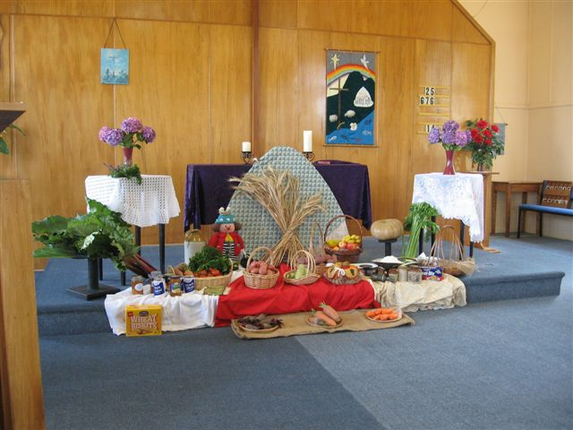
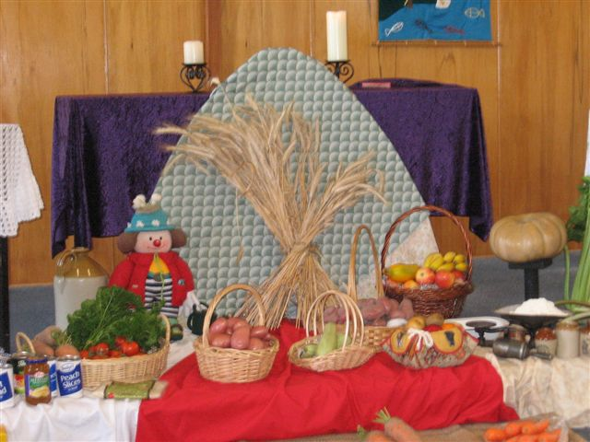
Photos from Mosgiel Harvest Festival Sunday 14th March


My thoughts are turning to preparations for the 120th anniversary of what was then called the Dunedin Central Mission, marking the occasion when the Reverend William Ready commenced his mission work in the lower Octagon, then surrounded by the hotels, brothels and drinking dens which attracted idlers and the urban poor.
Ready was himself the product of the London slums, one of the lucky boys saved from its squalor and hopelessness by an act of charity. He became a minister of the Bible Christian Church (a smaller offshoot of Wesleyan Methodism) and was sent to New Zealand in 1887. When he came south from Christchurch in May 1890, charged to do a similar work, he immediately began in the way he believed was most appropriate—he stood on a soap box, sang a gospel song, drew a crowd and invited them to worship the next day.
The song Ready chose to sing to this mostly male audience (for no decent woman would have ventured into such a public area at night) was ‘Where, O where is my wandering boy tonight?’ written in 1877 by the American Baptist preacher, composer and gospel song writer Robert Lowry.
The choice of such a song to carry Ready’s message is an interesting one.
‘Where, O where is my wandering boy tonight?’ is a musical setting of a story poem: a popular art form still used for religious and social purposes. It is offered in a traditional site for social work in the 19th century: not in a church or on a door-knocking campaign, but in a public arena where men congregated to drink and socialize. It is squarely focused on a contemporary social problem that is still with us—alcohol abuse. Its target audience are those disconnected from their families, mostly poor and probably out of work.
Its lyrics tell of a mother grieving for her ‘lost’ son: actually an up-to-date, feminised version of Jesus’ story of the Prodigal Son (telling such stories for a persuasive purpose is a classic and very ancient strategy.) Its address is to simple, deep emotions: it doesn’t threaten or try to terrify its audience with hellfire punishments as earlier preachers and some modern ones have tried to do, or attempt to persuade them as modern liquor and driving advertisements do, using factual information about the awful consequences of their behaviour. Its essential appeal is to a nostalgic sense of the warm and happy security provided by the listener’s family in early childhood (a piece of shrewd psychology). It goes lightly on religion: Jesus appears only appears in the final verse, where he is identified with the mother-figure.
Although much has changed in the social scene (though the Octagon is still a ‘dangerous’ place late at night), and Dunedin Mission activities have shifted to other problem areas like early childhood education, prisoner rehabilitation, dysfunctional families and training for re-employment—that is, to the underlying causes of social problems—the appeal is still to heart and mind, as it was in Ready’s song.
There is another connection, too.
The musical setting of this hymn, which reached the Chapman-Alexander mission hymnbook known as Alexander’s Hymns No 3 and was used widely in New Zealand, was written by Robert Harkness, an Australian musician who travelled extensively in round-the-world tours as a pianist with some of the leading evangelists of his day. He himself wrote several hundred gospel songs which were featured in these campaigns, and compiled a popular correspondence course on ‘evangelistic’ piano playing. Robert was the uncle of the Reverend Howard Harkness, who was minister here in Dunedin at Mornington Methodist Church from 1942-46.
Colin Gibson

