
Dunedin Methodist Parish
Finding good in everyone Finding God in everyone
www.dunedinmethodist.org.nz

Presbyters: | Rev. Stuart & Rev. Cornelia Grant | 453 6762
Parish Stewards: | Dr George Davis | 453 6540
 | Dr Richard Cannon | 477 5030
 | Mrs Fay Richardson | 489 5485
Tongan Steward: | Mr Palanite Taungapeau | 456 3144
Parish Office: | Stuart: parish@dmm.org.nz  Cornelia: scch.grant@xtra.co.nz  Sarah: sarahc@dmm.org.nz | 466 4600

PARISH BULLETIN
23rd May 2010

WORSHIP FOR SUNDAY 30th MAY 2010
9.30am |  | Mornington | S Grant
9.30 am |  | Mosgiel | D Phillipps
11.00 am |  | Glenaven | S Grant
11.00 am |  | Wesley | D Phillipps
1.00pm |  | St Kilda | S Finau
6.00pm |  | Broad Bay | No Service

PARISH COUNCIL MEETING: The next meeting takes place on Wednesday, 26 May, 7.30pm at Wesley Church. Copies of the February minutes and the agenda are available at church this morning.

EXPLORERS GROUP meets at 4-30pm on Sunday 30th, in the Mornington Methodist Church lounge. Suggested topic for discussion; The Future of the Church.

MORNINGTON METHODIST WOMEN’S FELLOWSHIP
The Afternoon Group meets again on Wednesday 26 May at 2pm when Cynthia Duncan will speak about her brooch collection. Cynthia invites members to bring their special old brooches to the meeting, too.
Please remember the 2009-2010 APW/MWF Special Project, “Supporting Youth – They’re Worth it!” The New Zealand Presbyterian and Methodist churches’ youth ministries will share a portion of the money raised. The remainder will be donated to Christian World Service to support Nicaragua’s CEPAD Development programmes.

HOLY COMMUNION SERVICES IN JUNE
In June we will celebrate Holy Communion in all churches on the second Sunday of the month, 13 June, instead of on the usual first Sunday. The reason for this is that both Stuart and Cornelia will be representing the Methodist Church at the 150th anniversary service of Knox Presbyterian Church.

TAX CREDIT
If you are a member of the Parish Stewardship scheme, received a receipt for your offering over the tax year April 2009 – March 2010 and have paid income tax over this period, you can claim a tax credit from the IRD. You can claim a tax credit of one third of the amount you have donated to the church up to a maximum of your income tax paid. Many members of the Parish Stewardship scheme claim this tax credit and donate some, or all, of it to the Parish. This donation then qualifies for a tax credit in the following tax year. Thus the amount given to the Parish can increase significantly each year. Such donations of tax credits are an important source of income for the Parish as weekly contributions from congregations are decreasing, and costs are increasing, from year to year. If you would like an IRD tax credit claim form (IR526) and/or instructions on how to complete the form, please contact the Stewardship Recorder for your congregation, or Parish Steward Richard Cannon.

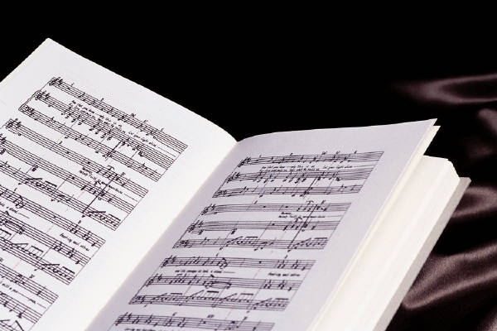
HOPE IS OUR SONG
Colin Gibson (phone 4536662) has a few copies of the new hymnbook, Hope is our Song, for sale at the reduced price of $25 (plus postage). This handsomely produced hymnbook would make a fine gift for a friend or yourself. As well as the best new hymns of Shirley Murray, Marnie Barrell, Bill Bennett, Bill Wallace and several Dunedin and Otago writers, it contains a number of new hymns and older favourites by Colin Gibson. The book is already into its third printing; get yours now.

HAPPY BIRTHDAY
To the following children celebrating birthdays:
29th – Ronan Shanahan



I was saddened to read in the Otago Daily Times just a day or so ago that vandals had damaged the protective fence surrounding the Orokanui Ecosanctuary, making it possible for animal predators, the invaders our ancestors brought with them, to re-enter that priceless place and threaten the survival of the rare native birds and helpless creatures placed inside its wall.

Thoughtless they may have been, rather than deliberately vicious (I mean the human vandals), but there is a spirit of unthinking destructiveness abroad in our community, a mindless animus against whatever appears to be an obstacle to the free expression of their own self-importance, their self-congratulatory defiance of ‘the rules’ of their community.

At worst, the same spirit of rampant egotism sets out to destroy or damage the beautiful, the rare, the frail, the costly, the work of many others—as in the case of the Sanctuary where volunteers have put in, and still put in endless hours to recreate just a little bit of the natural paradise which once existed in the hills and valleys of this region—before the last trees and ferns went down before settler axes, the last native birds died in the fires set alight by settler farmers, and the last kiwi was killed by one of our imported domestic ‘pets’.

Typically, walls and fences, symbols of the barriers society puts up to control territory or protect what is valuable and fragile are targeted: either to be torn down or ‘tagged’, that is, sprayed with graffiti declaring the tagger’s self-importance and right to self-gratification.

I resent and deplore the vandal’s presumption that he (or she) can behave as if the earth was in our hands to do with it whatever we wished; as if our scientists had never discovered the network of connections that places us within an ecosystem whose destruction will destroy us; as if our society had never realized that we are stewards of the earth, not its owners.

And I particularly resent news of such careless vandalism because only a few weeks previously I had wandered the tracks of the Sanctuary with my daughter, both of us full of wonder at a world filled once again with bird song, a green world where ancient miro, rimu, totara and tree ferns towered above us, a world where a fearless kaka hung by his huge beak from the netting of his aviary inches away from us, and looked at us with curiosity equal to our own. A sanctuary indeed—in the religious sense of a sacred space where retribution and destruction were forbidden. A place where one could catch just a glimpse of the earthly kingdom of God, and the deep connection of humanity with the natural world which is our graciously given habitat.
Colin Gibson

