
Dunedin Methodist Parish
Finding good in everyone Finding God in everyone
www.dunedinmethodist.org.nz

Presbyters: | Rev. Stuart & Rev. Cornelia Grant | 453 6762
Parish Stewards: | Dr George Davis | 453 6540
 | Dr Richard Cannon | 477 5030
 | Mrs Fay Richardson | 489 5485
Tongan Steward: | Mr Palanite Taungapeau | 456 3144
Parish Office: | Stuart: parish@dmm.org.nz  Cornelia: scch.grant@xtra.co.nz  Sarah: sarahc@dmm.org.nz | 466 4600

PARISH BULLETIN
20th June 2010

WORSHIP FOR SUNDAY 27 JUNE 2010
9.30am |  | Mornington | G Hughson
9.30 am |  | Mosgiel | E Merrett
11.00 am |  | Glenaven | G Hughson
11.00 am |  | Wesley | E Merrett
1.00pm |  | St Kilda | P Taungapeau
6.00pm |  | Broad Bay | No Service

BROAD BAY MID WINTER CELEBRATION today at 1pm, Broad Bay Church. Pot Luck lunch.

EXPLORERS GROUP
Meets at 4-30pm on Sunday 27th June in the Mornington Lounge. Continuing discussions on the future of the Church.
All welcome.

PF & R COMMITTEE meets on Thursday 1 July, 7.30pm at the Mission Office. NOTE: Changed from 24 June.

TERTIARY STUDENT PANEL NEXT SUNDAY
Next Sunday at Mornington, rather than a sermon, Greg Hughson (Otago University Chaplain) will interview a panel of University students from Methodist families here in Dunedin. These students have "grown up" in our Parish as children and/or teenagers. They will be invited to share about their studies and their experience of being a University (or Polytechnic) student today. There will be time for questions and discussion. Please let Greg know if you know of any students who would like to be part of the panel (Ph 479 8497, greg.hughson@otago.ac.nz). Students who have not grown up in our Parish are also welcome to be part of the panel.

WESLEY MWF
The annual meeting of the Wesley Methodist Womens Fellowship will be held at the home of Mrs Ivy Reggett, 146 Surrey Street at 1.45pm on Thursday 1st July.

DUNEDIN ABRAHAMIC INTERFAITH GROUP & OTAGO UNIVERSITY CHAPLAINCY – 2010 PEACE LECTURE
Chaiwat Satha-Anand, Professor of Political Science at Thammasat University, Thailand. “Overcoming cultural resistance to non-violence"
Burns 1, Lecture Theatre, Monday 12th July 5.30pm (supper to follow).

SYMPATHY
Our sincere sympathy goes out to Sally Weston (Mornington) and her family on the death last Friday of Laurie. We will miss Laurie in many ways, particularly for his warm personality and his cheerful good humour.
Our deep sympathy also to Dave and Jan Stewart (Glenaven) on the death of their 2 day old grandson, Daxton.
We offer our prayers and loving support.

HAVE YOU VISITED OUR PARISH WEBSITE RECENTLY?
The address is always on the title page of the weekly bulletin: www.dunedinmethodist.org.nz
If you have internet access and miss out on a bulletin, you can always check up on events etc. by visiting the website.
Articles, including the weekly “Connections” articles, sermons, photos etc. are steadily being added.

RADIO CHURCH is broadcast every Sunday at 8.30am on Toroa Radio, the local community radio station, on 1575kHz AM. You may like to listen in. If you know someone who is shut – in, let them know these details.
Clergy from the Anglican, Christian Churches (Church of Christ), Methodist, Presbyterian and Roman Catholic Churches pre-record the half hour services for the weekly broadcasts.



Winter solstice

“When I look at your heavens, the work of your fingers,
the moon and the stars that you have established;
what are human beings that you are mindful of them,
mortals that you care for them?” (Psalm 8:3-4)

We’ve had floods, landslips, heavy snow in places, and now frosts, and we’re all feeling the cold! It’s winter! The sun has turned his face away – or more accurately, our part of the earth has turned away from the sun. However we are nearly at the shortest day, so this is celebration time! The light will return, the days will get longer.

Some of us may also have been celebrating Matariki, the Maori New Year, when a set of stars also known as the Pleiades rise again above the horizon in the north-east.

If I am up in the night I always like to look out our window that faces south/west to see the Southern Cross. Early in the night I can see the whole cross with the pointers leading “down” to it, but later on just the pointers are there, while the Cross has set beyond the house next door!

And, back to earth -- yes, sometimes we feel dismayed when we hear of natural disasters, earthquakes and volcanic eruptions, tornadoes and tsunamis. We are indeed living precariously on an unstable planet. Our earth is an active living thing. When, in some far distant future, the volcanoes stop erupting, and the plates stop moving, they tell us, then the earth will have died and everything on it. Let us rather rejoice in all the good things about our earth, sunrise and sunset, season following season … yes, even winter!

When Colin Gibson led a service of worship last year based on the Blessings of winter, he invited feedback from the congregations. “Tracery of trees bare of leaves, and the dappled light"; “A roaring fire, and a good book”; “Bright clear days after frost"; “Dawn – the colours of the sunrise”; “The beach, the wind, wild waves”; "Fellowship with family and friends" were some the responses (they are still on our website under the title In praise of winter!).

Just last week I noticed that many of the camellias in the lower Botanic gardens are in bloom. And you will have seen the autumnalis cherry trees in blossom, and bulbs showing green shoots, if not flowers, as yet – a promise of the spring to come.

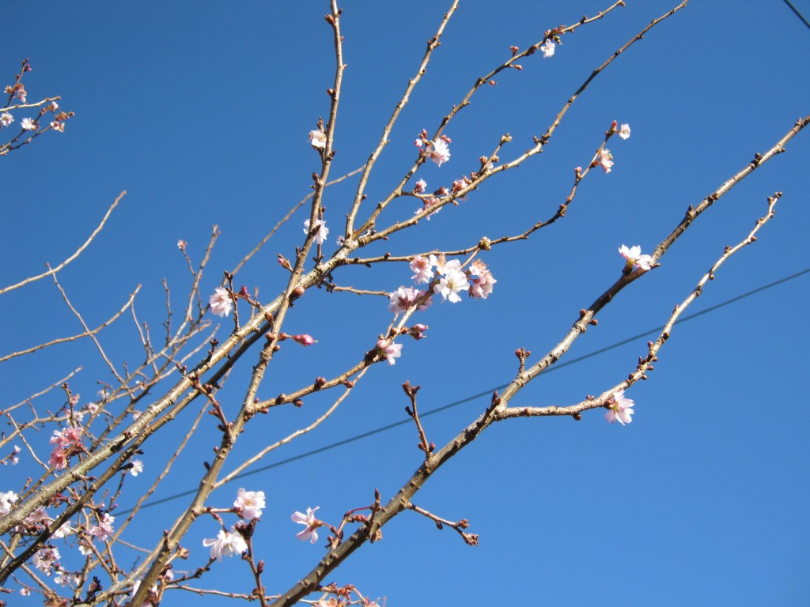
Psalm 104 is a wonderful hymn of praise to the Lord, the creator… “By the streams the birds of the air have their habitations; they sing among the branches. From your lofty abode you water the mountains; the earth is satisfied with the fruit of your work … I will sing to the Lord as long as I live; I will sing praise to my God while I have being … Bless the Lord, O my soul. Praise the Lord!”

-- Joan Robertson

