
Dunedin Methodist Parish
Finding good in everyone Finding God in everyone
www.dunedinmethodist.org.nz

Presbyters: | Rev. Stuart & Rev. Cornelia Grant | 453 6762
Parish Stewards: | Dr George Davis | 453 6540
 | Dr Richard Cannon | 477 5030
 | Mrs Fay Richardson | 489 5485
Tongan Steward: | Mr Palanite Taungapeau | 456 3144
Parish Office: | Stuart: parish@dmm.org.nz  Cornelia: scch.grant@xtra.co.nz  Sarah: sarahc@dmm.org.nz | 466 4600
PARISH BULLETIN
22nd August 2010

WORSHIP FOR SUNDAY 29th AUGUST
9.30am |  | Mornington | S Grant
9.30 am |  | Mosgiel | G Watson
11.00 am |  | Glenaven | S Grant
11.00 am |  | Wesley | G Watson
1.00pm |  | St Kilda | P Taungapeau
6.00pm |  | Broad Bay | No Service

PARISH STRATEGY FOR GROWTH & DEVELOPMENT
The Parish Property Finance & Resourcing (PF&R) committee has been considering the future of ministry in the Dunedin parish. It would like to see the Parish grow & develop & needs your help. We live in ever-changing times & so we need to constantly review the appropriateness of our services to our members and to our communities. The PF&R committee would like to hear your ideas for how to grow, develop & make more relevant the Methodist presence in Dunedin. We would like you, through your Leaders’ meetings, to answer the following questions:

1. What form of service best meets the needs of you congregation?
2. Who do you want to attract to your church?
3. What are their needs and how can you meet them?
4. What are our assets ie, our gifts & abilities, the things we do well?

Our strongest asset is the commitment, energy and ideas of our members. Please be enthused by our challenge. Talk with family & friends about creative ways to engage with our communities, serve our members, & celebrate our faith. Ideas submitted to the PF&R committee by Leaders’ Meetings will be discussed further at a Parish-wide meeting later in the year. For the Parish Stewards.

EXPLORERS GROUP meets at 4-30pm on Sunday 29th August in the Mornington Church Lounge, and it's proposed that we have further discussions based on the writings of theologian Karen Armstrong. All interested people welcome.

MOSGIEL LEADERS MEETING
Special Leaders Meeting for Mosgiel, Tuesday 31st August at 7.30pm to discuss details of the upcoming 125th anniversary.

BULLETIN NOTICES
As I will on leave, it would appreciated if any Bulletin notices for Sunday 29th August and Sunday 5th September could be in a day earlier than the normal deadline ie, Wednesday at midday.

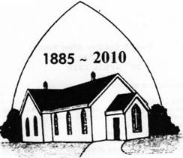
MOSGIEL 125th CELEBRATIONS
Is there anyone who has had an affiliation to MOSGIEL you are welcome to attend our 125th Celebrations on 21st November SERVICE 10am FORMAL DINNER 12noon,and Afternoon Tea if so please contact Elaine on 489 7663.

MORNINGTON ANNUAL CONGREGATIONAL MEETING takes place following a shortened service on Sunday, 12 September. Would those responsible for reports please ensure that they are delivered, preferably by e-mail attachment, to the office by Wednesday, 1 September, so they can be assembled into booklet form. Many thanks.

HAPPY BIRTHDAY
To Josh Brodie-Dixon who celebrates a birthday on 22nd August.

YOUTH SUNDAY was celebrated at Mornington with great enthusiasm last Sunday, as the Y@M group took the congregation on a whirlwind tour of several of the stories from the Acts of the Apostles. They made good use of the flat screen TV, showing news reports from the Judea Times. Many thanks to Ginny Kitchingman for devising the service with her usual imagination and leading the young people.

HELP WITH HOUSEHOLD ITEMS?
Mai Tamimi, Ph.D. student from Palestine, who many will remember was a guest speaker at one of our Open Education evenings, writes:
“Last Friday, a Palestinian family from Jordan arrived to Dunedin. The father will do his PhD on a scholarship from the University of Otago. Thank God that I was able to secure a place to house sit until tomorrow, then they will move to an empty house that they will rent tomorrow morning. They are seven people and the kids are young (1 year - 16 years old).”
The family have arrived from Palestine with just their clothes. If anyone can help with basic household items, e.g. bedding, kitchen ware, clothing, baby clothing, etc. pleas get in touch with Cornelia, ph. 453 6762.

WESLEYDALE TRUST
The Trust, which was set up following the sale of the former Wesleydale Camp in the Maungatuas, continues to provide valuable finance for ministry within the Dunedin Methodist Parish, adjacent Cooperating and union Parishes, and for hospital and tertiary chaplaincies. The main grants approved in the last financial year (July 2009 – June 2010) were:

350 Climate Change action $500
Flagstaff Union Parish after school club $800
Brockville Community Church (Youth camp) $6000
Tongan Methodist Fellowship (Easter Camp) $2480
Otago – Southland Synod (bringing Tongan
Youth group to Queenstown) $1000
Flagstaff Union Parish (support of community worker) $7000

Copies of the full report to the August Synod are available at the Parish Office (Phone Stuart at 466 4600).
Application forms have recently been sent out for the current financial year.

ABOUT PEOPLE:
Andrea and Eldon Mosley’s daughter Linda and husband Nathan had a baby daughter, Annabelle, on 12 August. Congratulations!
Sue Galloway is making good progress following her bike accident three weeks ago.

CONFERENCE REPORTS
Copies of the agenda, reports, and year book of the annual church conference are available at a cost of $45 if ordered before 30 September.
(Conference representatives have their paid for by their registration fee). Anyone wishing to place an order, please phone Stuart, 466 4600.

ALCOHOL – A NATIONAL CRISIS
Prof. Doug Sellman one of the Medical Spokespeople for Alcohol Action NZ spoke to the Central South Island Synod recently. He explained if alcohol was being introduced for the first time in Aotearoa-New Zealand, it would be named as a ‘Class B’ restricted drug because of its widespread addictive and social effects. Prof. Sellman was seeking the church’s support for a stand to change the laws so that alcohol was neither freely available nor prohibited but somewhere in between. The following is taken from Alcohol Action’s website, www.alcoholaction.co.nz

“There is a national alcohol crisis. However, this crisis is under-recognized because we have become numbed by the unrelenting presence of alcohol-related problems. The national alcohol crisis has become our way of life.
- At least 25% of New Zealand drinkers are heavy drinkers
- A third of all police apprehensions involve alcohol
- Half of serious violent crimes are related to alcohol
- 60 different medical conditions are caused by heavy drinking
- Up to 75% of adult presentations at Emergency Departments on Thursday, Friday and Saturday nights are alcohol-related
- Over 300 alcohol-related offences every day
- Over 500 serious and fatal injury traffic crashes every year
- At least 600 children born each year with fetal alcohol spectrum disorder
- Over 1000 alcohol deaths in New Zealand every year
- 17,000 years of life per year are lost through alcohol

But, figures and statistics such as these do not adequately capture the misery, pain and loss that many New Zealand families suffer as a result of excessive alcohol use. However, they go some way in describing the awkward truth - alcohol is causing considerable damage to our society.”

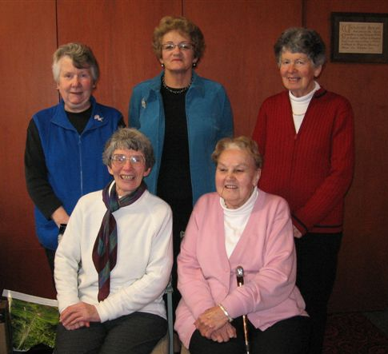

M.W.F. District Executive for 2010 Back row: Margaret Connor Treasurer, Earlene Owens President, Sally Weston Missions, Front row:
Fay Richardson Secretary, Ivy Reggett Hospitality

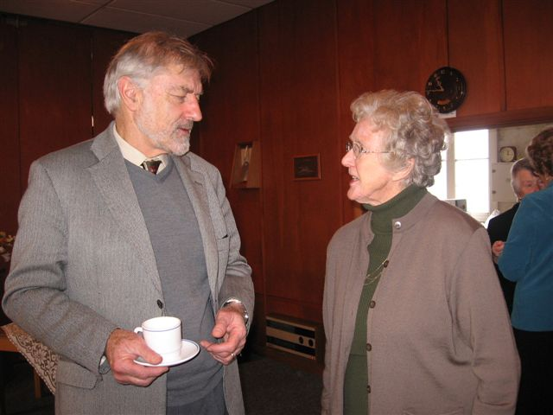

Rev Stuart Grant & Joyce Patton deep in conversation at the MWF District AGM


The world will never be allowed to forget 9/11. America sees to that, and whether it is by the persistent and erroneous notion that it was a calculated attack in a holy war against “Christian democracy”, or any one of a number of conspiracy theories that purport the government of Geo W. Bush was party to a nefarious plot to curry public opinion in favour of an attack on Iraq, 9/11 will doubtless remain for many years to come as a rallying point for the political and religious right in that country to ferment virulent anti-muslim propaganda.

9/11 will always make a story. Footage of airliners flying headlong into iconic buildings and panic stricken of New Yorkers fleeing the Twin Towers holocaust, will remain etched in the collective mind of Americans. That much is understandable.

The 10th anniversary is but one year away, and the question yet to be answered is whether the emotional observance of that terrible day, one year hence, will continue to be used by the extremists of the far right, hardline Republicans, the military establishment, Fox News, and a host of tele-evangelists, to continue their relentless campaign against all things Islamic - or whether a softer, more tolerant voice will be heard, of reason and sanity, that clearly and fairly distinguishes between mainstream Islam and radical Al Qaeda is a question of supreme importance far beyond the bounds of the United States.

It is in the context of that as yet unanswered question, that the current fiercely waged debate in the U.S. over proposals to build a Muslim mosque and community centre within not much more than a stone’s throw from Ground Zero warrants our attention.

Imagine, if you will, the courage, ( or is it the foolhardiness) of such a proposal - to build a major centre for the practice of Muslim religion and culture adjacent to the site where radical Al Qaeda wrought death to 3000 Americans and destruction to two of the proudest landmarks of American life and commerce. Claiming that every fibre of American public opinion is incensed at the very idea, that American pride and honour is at stake, a barrage of opposition has been mounted, one with the potential to divide America on racial and religious grounds and even to threaten the government of Barack Obama. One commentator put it recently - “the rise, or not, of an Islamic powerhouse so close to America’s ‘holy ground’ has the potential to influence the shape and direction of government in this country for the next decade. This insult to 3000 slaughtered Americans must be stopped.”

An unlikely hero in this escalating saga is New York Governor, Michael Bloomberg, a former Wall St mogul, long-time Republican, and a practicing Jew. Every one of these affiliations would, one might think, place Mr Bloomberg in the camp of powerful conservative forces determined to stop the proposal in its tracks. But not so. As the boss of City Hall in Manhattan, the Mayor has led his administration to approve the plan, and is leading the charge for the Centre to go ahead.

It is useful to note Mr Bloomberg’s stated reasons for his courageous and outspoken support. They are said to be both civic and personal. For years, with a mix of care and impatience, he has been encouraging New Yorkers, including the families of 9/11 victims, to move beyond the horrific memories of nine years ago. As if guided by an instinct that he must practice what he preaches, he took the initiative to meet the Muslim principals, among them Imam Feisal Abdul Rauf, a controversial New Yorker with a track record of advocating for moderate liberal Islamic programmes in cosmopolitan Manhattan. While heavily condemned for doing so, Bloomberg became personally impressed by the integrity of the people, and on that basis openly refuted claims by opponents the centre would be used to harbour radical elements plotting to inspire acts of terror. The, only weeks ago Mr Bloomberg approached an adviser on Muslim issues, Fatima Shama, a Palestinian-American commissioner on immigrant affairs and asked her what she thought of the project. Ms Shama, it is said, framed the issue in personal terms. She has three sons, she said, but there is no place in all of Manhattan for them to share their faith with their Jewish and Christian friends. “This could be such a place,” said the Mayor, and gave wide publicity to the conversation.

What a role model. Friendship, not prejudice. Relationship, not reputation. Trust, not fear.

We should not gain the impression the Mayor is alone. As the controversy has mounted, liberal Christian and Jewish interests in the Big Apple have weighed in behind him. The future, or the non-future, of the bold project, has assumed a symbolic importance far beyond New York, and the President himself, who his opponents are openly accusing of being a closet Moslem, is fast approaching the time when he must clearly declare himself for or against. Clearly he campaigned for just such bold initiatives as the Mayor is advocating. It will be a moral test of his presidency.
As with many things in America, their influence on our media, and thus on our opinions, can hardly be overestimated - whether for good or for ill. We have made much of the Charter for Compassion as the way forward for interfaith dialogue, but it needs to be more than an academic discussion among theologians. Mayor Bloomberg is a Hero of Compassion. He is “doing” the Charter, moving beyond lip service, and we may observe at what cost, and to what extent he is being demonised by the apostles of prejudice.

Could it be that at the site of infamy, in arguably the world’s greatest city, mecca for tourists from every country and culture, a landmark of tolerance, respect and peace could yet arise that in time will stand as an alternative testimony to the real spirit of Islam, a spirit of compassion, “breaking down the walls of division.” (Eph 2: 14)? Hope springs eternal. Pray for this mayor.
Ken Russell

