
Dunedin Methodist Parish
Finding good in everyone Finding God in everyone
www.dunedinmethodist.org.nz

Presbyters: | Rev. Stuart & Rev. Cornelia Grant | 453 6762
Parish Stewards: | Dr George Davis | 453 6540
 | Dr Richard Cannon | 477 5030
 | Mrs Fay Richardson | 489 5485
Tongan Steward: | Mr Palanite Taungapeau | 456 3144
Parish Office: | Stuart: parish@dmm.org.nz  Cornelia: scch.grant@xtra.co.nz  Sarah: sarahc@dmm.org.nz | 466 4600
PARISH BULLETIN
19th September 2010

WORSHIP FOR SUNDAY 26th SEPTEMBER 2010
9.30am |  | Mornington | S Grant with Jan Bain from Approach Community Learning
9.30 am |  | Mosgiel | Lead Worship with Bronwyn Powell-Grubb, Social Services Practice Leader
11.00 am |  | Glenaven | S Grant
11.00 am |  | Wesley | Lead Worship
1.00pm |  | St Kilda | P Taungapeau
6.00pm |  | Broad Bay | No Service

CANTERBURY EARTHQUAKE
Since last Sunday’s bulletin, much more news has come through regarding the earthquake and the massive damage it has caused. Last week discussions as to how the wider church might help were just beginning. Since that time, a plan of action has been formulated and details of how donations will be used are set out in the messages letter from the President and Vice President of our Church, Alan Upson and Lana Lazarus on page 7, from the General Secretary, David Bush on page 8.

CELLISTS OF OTAGO LAST CONCERT 2010 SEASON
On 19 September at 3pm in the Roslyn Presbyterian Church 19 Highgate (South end) the Cellists of Otago will present a concert featuring works by Handel, JS Bach, Schumann, Chopin, Beethoven, Cassado, Hewitt-Jones and Sir Arthur Sullivan. There is material here for all tastes! Duncan Watts and Kathy Thompson (flutes) and Myles Chen and Abby Lute (cellos) will be the featured artists. Come along to hear these talented folk play. This concert will be a fundraiser for the Hospital Chaplaincy - please support this worthwhile cause.

HOSPITAL CHAPLAINCY WEEK: The Interchurch Council on Hospital Chaplaincy (ICHC) is holding its annual appeal this week. Appeal envelopes are available at our churches this Sunday. The theme of the appeal is Sudden Crisis, reminding us that we can all face situations such as traffic accident (and earthquakes) which can turn our lives, and those of our loves ones, upside down. At such times, hospital chaplains can fulfil an important role, and they deserve our support. It is unfortunate that this appeal comes at the same time as the earthquake appeal, - but that’s life! Please respond as you are able. This is a good opportunity to thank Dr. Greg Jones (Mornington) for representing the Methodist Parish on the Otago Healthcare Chaplaincy Support Trust.

STATIONING FACE-TO-FACE MEETING
The Stationing Committee, which met on 25 August, matched the Revd Siosifa Pole with the Dunedin Methodist Parish, as did our Parish Council. The next step in the stationing process is for a face-to-face meeting between Siosifa and the Parish. Siosifa and his wife Naomi will visit Dunedin on 24-26 September to talk with people from the Parish and to look at the Churches, and Parish properties. There will be a face-to-face meeting of Siosifa with members of the Parish on the evening of Saturday 25 September at Mornington Church. This meeting will start with a pot-luck meal at 6.00 pm. The face-to-face meeting after the meal (at approximately 7 pm) will give Siosifa a chance to introduce himself, and us to do likewise. There will be the opportunity to discuss Siosifa’s ministry expectations and those of the Parish. The objective of the meeting is to confirm, or not confirm, the match between Siosifa and the Dunedin Methodist Parish. All parish members are invited to participate in this important meeting.

THE CITY OF DUNEDIN CHOIR
Will give a repeat performance of “Zimbe” (Come sing the Sings of Africa) at a benefit concert for the Canterbury Earthquake next Sunday afternoon, 26 September, 4pm in the Kings and Queens College Performing Arts Centre, Bayfield Road.
If you missed the original performance, don’t miss this one. Described as “African folk with a jazz twist”, it really goes with a swing.

MORNINGTON MWF
The next Meeting for the Mornington MWF will held on 29th September at
2 p.m. in the Church Lounge. The Guest Speaker will Mrs Joan Robertson - the subject - Ancestor Anecdote Adventures.
Thanks to all who helped - in any way with the funeral held in the Church on Friday the 10th September.

MOSGIEL STUDY GROUP
E100 study group meets every Wednesday at 1:30pm except 2nd Wednesday when it’s Mid~Week service.

MOSGIEL MWF
Next meeting is 5th October 1:30pm when Mrs. Ruth Watson will speak to us “Life as a Minister’s wife in Australia”. All welcome.

PEOPLE NEWS
It is with sadness that we acknowledge the death of Merv Colson a much loved member of the Mosgiel congregation for several years Merv passed away on Thursday 7th Sept. aged 82yrs. Our Sympathy to all his family & friend Shirley Garside.

HAPPY BIRTHDAY to Daniel Ahn who celebrates a Birthday on 24th September.

THE KAPITI UNITING PARISH has affirmed the Stationing Committee’s matching of the Rev. Cornelia Grant.

MONEY FOR EARTHQUAKE-STRICKEN CANTERBURY
The September Open Education session, in which Professor Andrew Bradstock and Dr Najibullah Lafraie, both Otago University staff members, discussed the question ‘Does religion help or hinder the quest for peace?’ drew a full church, with many attending from outside the usual church circles.
Especially notable were Christian and Muslim members of the Abrahamic Interfaith Group led by Greg Hughson, Sea of Faith members and Christina Gibb, fearless advocate for the Palestinian Arab people. There were probing questions from the audience and all agreed to hold a similar session next year to follow up some of the areas only briefly touched on during the night. There was a large group of pre-talk diners, too (more than forty of them), who expressed their satisfaction at the generous meal laid before them by Judy Russell and her helpers.
All proceeds were given to the Dunedin Mission to distribute through the Christchurch Mission as they work to support people in the earthquake-stricken city of Christchurch and its surrounding towns. The cheque was for $896.60, quickly made up to $900. Is there anyone who would like to make the grand total $1000? A great result from a special evening.



In these early days of recovery in Christchurch, the commitment and attention of government and by the citizens to each other is heartening. Cantabrians are in great upheaval, with a looming accommodation crisis, the refiguring of many of their common spaces, economic uncertainty as businesses decide whether to reopen; and the stress, anxiety, and grief that so often comes with sudden change.

It is therefore appropriate that the nation show solidarity and offer whatever assistance can be provided, much of which may be needed over several years.

Despite this timeline, no-one is suggesting that Cantabrians are at fault, or have inadvertently contributed to their current misfortunes, nor will it be suggested in 6 months time that the victims of the earthquake need to have their “dependency” on aid fixed with tough love.

Yet this is precisely the stance of the Government’s Welfare Working Group as it considers the “welfare dependency” of the victims of 5 successive economic earthquakes (the two oil shocks in 1973 and 79, the 1984 economic liberalisation, the 1991 “Mother of All Budgets”, and the 2008 credit crunch), of the unceasing tremors of a low-waged economy (a natural result of the quest for low inflation as predicted by the Phillips Curve in 1958).

How is it that the myth of “dependency” with its assumptions of fecklessness, laziness, corruption, and belief that benefit levels are if not luxurious then at least sufficient, has taken hold in this way? For it is easy to disprove all those assumptions … most beneficiaries loathe their reliance on benefits, would love to be able to work, are conscious that their income comes from the taxpayer, and struggle on an income that is half the poverty line.

How is it that we can look at our neighbours with less than love, less than respect, even scorn? What happened to loving our neighbour as we love ourselves? Well, I have a radical suggestion: I think we are loving our neighbours as ourselves, just not loving ourselves particularly much.

The clue lies in that Phillips Curve. For over 60 years, the inverse relationship between inflation and unemployment has been well known: higher inflation is generally matched by lower unemployment; lower inflation is matched with higher unemployment.

Managing inflation keeps consumer goods and services affordable. Managing unemployment ensures people can support themselves. (Notice that one mentions “people”, the other focuses on “things”.) Since the 1989 Reserve Bank Act, successive New Zealand governments have focussed all monetary policy on inflation.

We have not sought balance; we have absolutely chosen things over people and in doing so have bought into the psychologically and spiritually damaging effects of defining ourselves by what we buy: people struggle to form a relationship with their own self, spirituality, or empathy when things are all that matter. It is not surprising that people also struggle to form a relationship with others with things in the way.

Self knowledge, spirituality, and empathy arise from reflection, honesty and courage: none of which can be bought, but all of which are nourished by meaningful activity, joining with others toward a common purpose, the interpersonal ebb and flow, and the consequential learning, of employment (in its broadest sense of “to make use of, to apply, to occupy or devote”).

The Good Samaritan did not rush on late for the opening of a sale. He stayed and employed what he had to the benefit of the wounded stranger. It is what New Zealand must return to, not just for Cantabrians, but for all who have suffered upheaval beyond their control.
Laura Black

Earthquake Damaged Church Properties in Canterbury:

Seriously Damaged:
- Durham Street
- St John’s Bryndwr
- Richmond Church, Stanmore Road
- Woodend Church

Lower Level Damage:
- Wainoni Church
- Papanui Church
- Kaiapoi Church office
- Beckenham Church
- Halswell Union
- Linwood Ave Church
- Ashburton Church
- Wesley Hospital
- New Brighton

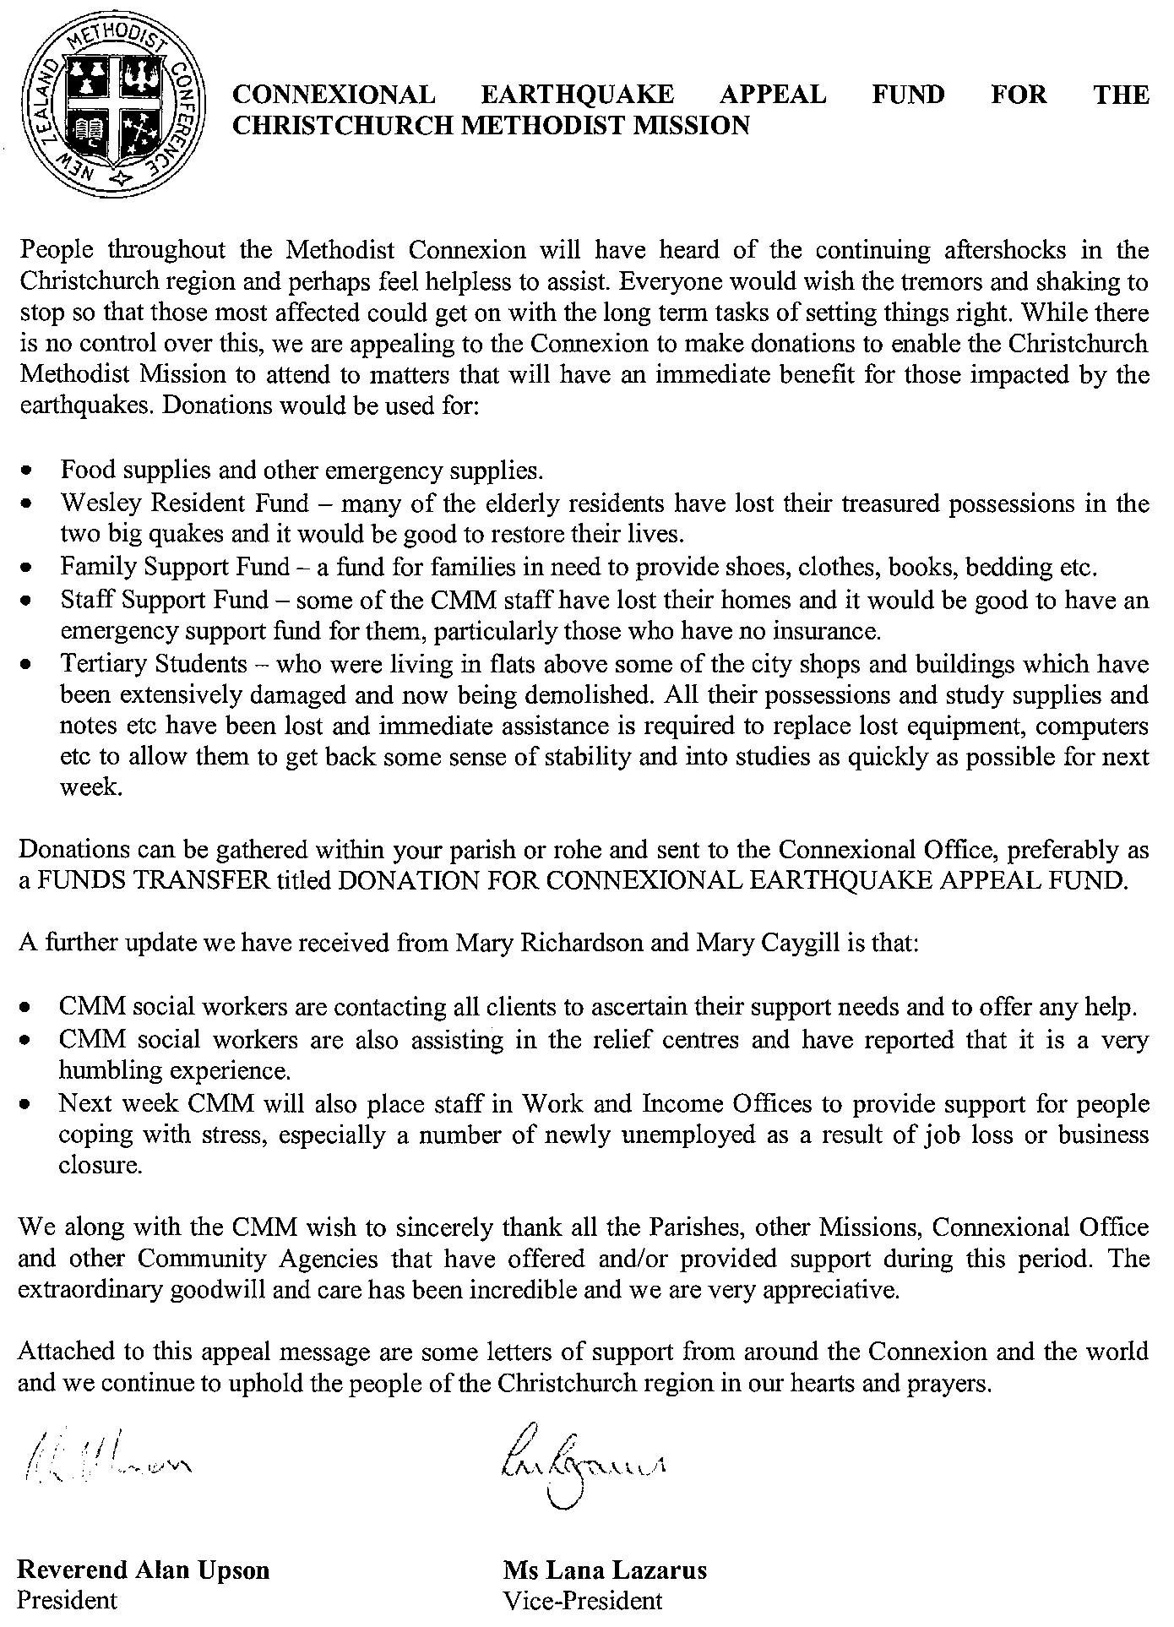

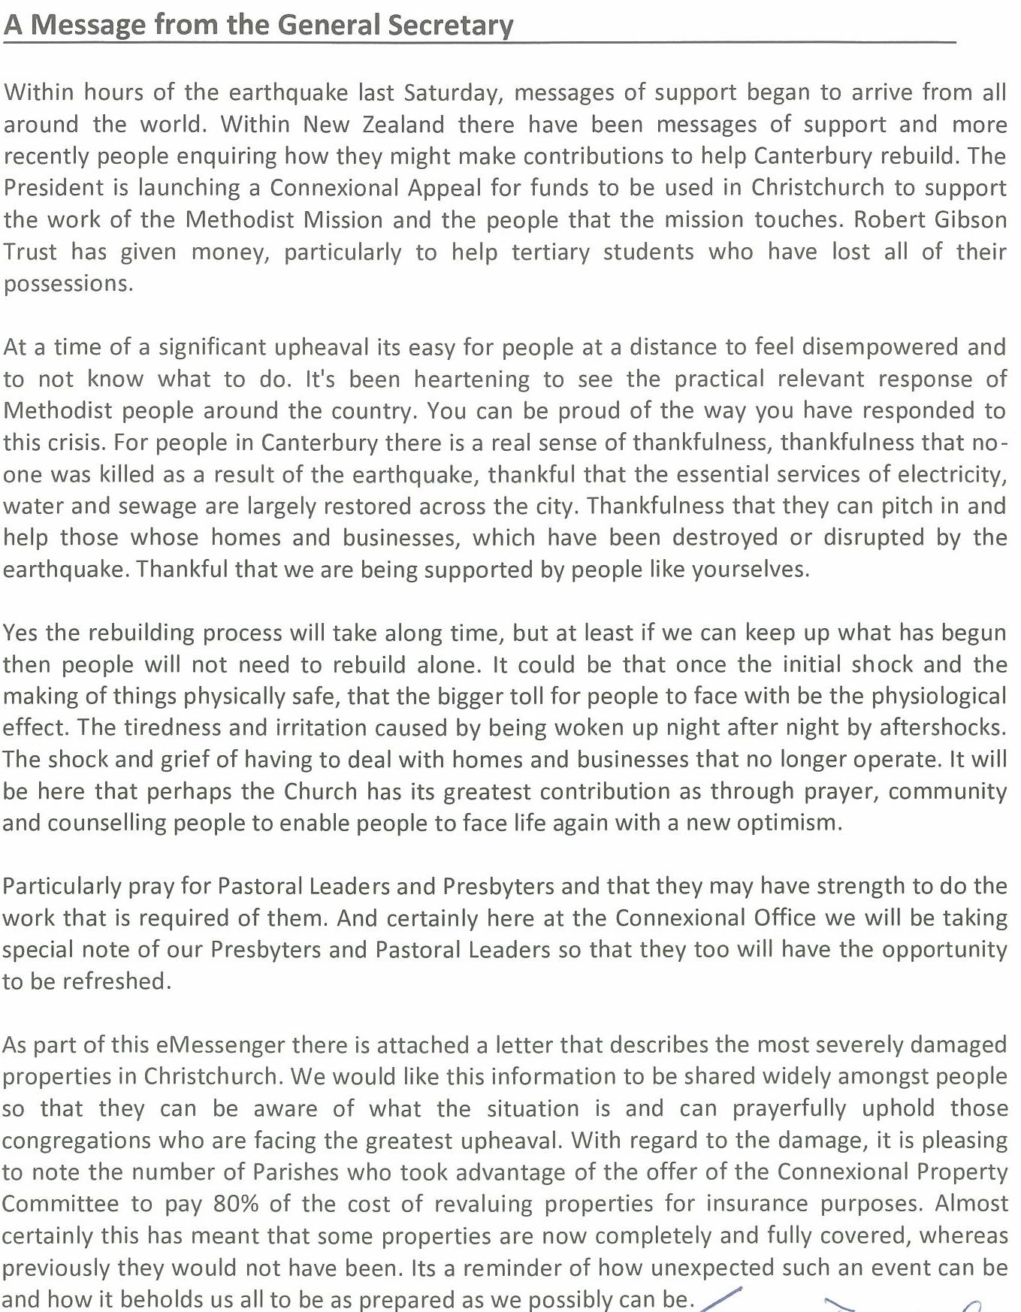
- David Bush, General Secretary

(See page 6 for list of the most severely damaged properties)

