
Dunedin Methodist Parish
Finding good in everyone Finding God in everyone
www.dunedinmethodist.org.nz

Presbyters: | Rev. Stuart & Rev. Cornelia Grant | 453 6762
Parish Stewards: | Dr George Davis | 453 6540
 | Dr Richard Cannon | 477 5030
 | Mrs Fay Richardson | 489 5485
Tongan Steward: | Mr Palanite Taungapeau | 456 3144
Parish Office: | Stuart: parish@dmm.org.nz  Cornelia: scch.grant@xtra.co.nz  Sarah: sarahc@dmm.org.nz | 466 4600
PARISH BULLETIN
21st November 2010

WORSHIP FOR SUNDAY 28th NOVEMBER 2010
9.30am |  | Mornington | S Grant
9.30 am |  | Mosgiel | C Grant
11.00 am |  | Glenaven | S Grant
11.00 am |  | Wesley | C Grant
1.00pm |  | St Kilda | A Finau
6.00pm |  | Broad Bay | No Service

WARMEST CONGRATULATIONS to the Mosgiel congregation on celebrating their 125th anniversary today. We extend a special welcome to all who are gathering today for the commemorative service and lunch. Many thanks to all who have worked hard in the preceding weeks and months to organise the event.

WESLEY METHODIST WOMEN’S FELLOWSHIP
Is holding a Bring & Buy Sale on Sunday 28th November 2010, after the Morning Service. This is being held to raise funds for the 2010-2011 Special Objective which is Supporting Haiti through Act Alliance and Habitat for Humanity in NZ. The support of all Wesley Congregation would be greatly appreciated.

DATES TO NOTE:
THE PARISH COUNCIL meets for the last time this year on Wednesday 24 November, 7.30pm at Mosgiel Church.

PROPERTY FINANCE AND RESOURCING COMMITTEE meets on Thursday, 2 December, 7.30pm at the Mission Office.

WESLEY MWF
Final meeting for 2010 will be held at St Barnabas Rest Home on Thursday 2nd December at 12.30. Please come and share Christmas lunch with us, bring a friend. All welcome. Let Ivy or Joyce know if you will be there by 28th November.

MARY’S RETIREMENT PARTY: INVITATION
To help celebrate my retirement from university, my Mornington friends are cordially invited to join the party on Sunday 5th December at Mary and Sue’s place, 197 Balmacewen Road anytime between 2 pm and 6 pm. Afternoon tea refreshments will be on the go all afternoon, so please come and go whenever it suits you. Instead of presents we thought it might be fun to see how many goats we can buy for Ugandan families via CWS, so feel free to contribute towards that to mark the occasion if you wish.


DISTRICT METHODIST WOMENS FELLOWSHIP
AFTERNOON TEA PARTY

Saturday 4th December 2010
Mornington Church Hall, 2.00pm

Gloves to be worn, also gloves for display.
A story or two to be told.
One plate per car load, please.
Tickets $5.00 available from MWF members.

Anyone who can provide or needs transport phone Sally – 4544489

PARISH FAREWELL FOR STUART AND CORNELIA
There will be an afternoon tea at Mornington Church at 3.00 pm on Sunday 19 December at which the Parish will farewell Cornelia and Stuart. The afternoon tea will be preceded by a walk through the town belt to Mornington Church for those who want to participate. The afternoon tea will also include a short concert. More details will follow.

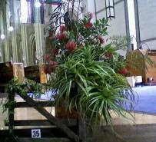
ECUMENICAL FESTIVAL OF FLOWERS IN PRAISE
The 44th Ecumenical Festival of Flowers in Praise will take place next year from Saturday February 12 to Tuesday February 15. It will be held as usual in St Paul's Cathedral in the Octagon, and we are delighted that Lynley Kloogh and Robyn Freeth will again create the display for our parish.
The theme for 2011 is to be "A beacon whose light must never die" (words from the hymn "For the might of your arm we bless you" by C.S. Horne), chosen to reflect the mission of the Otago Rescue Helicopter Trust who will receive the proceeds from the festival. The Committee were most impressed to hear of their emergency and intensive care rescue work, which often goes unpublicised.

"The Trust has the ongoing challenge of raising approx $400,000 to $500,000 per year to cover the unfunded fixed costs of providing the service and to update the emergency and life support equipment carried on the helicopter."--http://www.otagorescue.co.nz/about.php
There will be the usual plant stall at the Festival and your contributions to this are welcome.
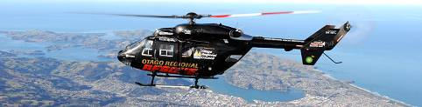

HAPPY BIRTHDAY to Darcy Pitts who celebrates a Birthday on 22nd November.

AMY MCLAREN
The death of Amy McLaren the other day at the age of 94 brings to mind a time when Dunedin Methodism included a church at St Clair. From 1923 until 1962 there was an active congregation there, and for a time a resident minister.
The McLaren family were among the founders of this Society. Her family, especially that of Margaret Newton, Amy’s sister, and friends from Dunedin South, gathered to farewell Amy and pay their tribute to the long life of a fine person.

BEREAVEMENT
We were saddened to hear of the sudden death last week of Kate Jarvis (formerly of Glenaven) in Sydney. Kate was a member of the Glenaven congregation for some years before moving to Sydney earlier this year. Our deep sympathy goes out to her family and friends.

ABOUT PEOPLE
Congratulations to Elspeth McLean (Broad Bay) on being awarded the Valpy Rosebow trophy for editorial excellence as Otago Daily Times health reporter; ”most notably regarding colonoscopies in Otago and her reporting of the neurosurgery issue in Dunedin” (ODT, 17.11.10);
Congratulations also to Sherilee Shackleton (Glenaven) on her graduation this week.


Inside/Outside

Hi Jo

As you know, I spend a fair bit of time at church – normally inside it, of course. But in recent months I’ve spent rather more of that time outside it, though not by very much – maybe by about a foot on average.

You see, a group of us has just finished painting the exterior walls and roof of the church. We repainted the roof green, but it’s not yet a green roof. I mean not in the latest sense of the phrase. So it missed out on getting a layer of living vegetation as an ecological contribution. Nor, for that matter, did we consider joining The White Roofs Project NZ, promoted as the fastest way of reducing global warming. As a congregation we might have earned an environmental award for our Streamscape Project but our consciousness raising has only gone so far. So we didn’t install solar panels either.

Be that as it may, being (rather than having) one foot outside the church made quite a difference to a number of my perceptions. In comparison with being inside the church, I noticed that –
On the outside:

- The elements are more raw and fluctuating. The unexpected seems less unlikely. What if a 7.1 earthquake were to strike the 80-year old two-storey brick hall? There are constant reminders of the ancient derivation of the terms “spirit” and “spiritual” from breath and wind, though I’m not sure where the wind-chill factor fits in. Temperatures seesaw. Paint may immediately steam on contact with hot iron and within an hour or so run with the cold. Inside is cosy and sheltered. We don’t want a draught .We complain if the heaters weren’t turned on early enough.

- The outlook is more stark and vast. From even our modest Mornington vantage point there are sweeping vistas of the Pacific Ocean, the Otago Harbour, and the main peaks of the Dunedin volcano, dwarfing the cluster of other buildings that surround us. The whole wide world is very present and pressing. Inside, our church is beautifully constructed and embellished, with an emphasis on the culture and history of the Christian faith.

- Even the human impact is less restrained and more variable. A fellow member calls out, “Say one for me while you’re up there.” A driver, frustrated at our obstruction of his preferred off-loading zone in the church car park, indulges in yelling out an unrepeatable version of road rage. Meanwhile, within the working bee itself, we get to know each other in ways that would be impossible in a month of ordinary Sundays and services. Inside we are more polite and predictable. The seats are comfortable. We take it easy.

In summary, when even just a foot outside the church, you may be perched up high but you don’t rule the roost. Gravity and the weather dictate the terms.

Four weeks ago in the “Connections” column, Aelred Edmunds wrote about the outdoor markets, saying that he often sees them as in some senses “a church in the open air”. He was encouraging us to recognise Christ in such environments, present as much outside as inside.

To that we might now add, “Admit more of the outside inside.” Sanctuaries meet the need for protection and even a little privacy. But they risk smothering the spirit. There’s a phrase beloved of real estate salespersons – “indoor/outdoor flow”. It’s very fashionable for domestic architecture but barely thought of in church design. While on the roof, I’ve sometimes wondered, “What should we do if we had to start all over again?”

Not so long ago a committee within our Parish asked members a series of questions about what form of service best meets our needs and the needs of those we want to attract to our church. Is this the time to fine-tune our worship or is it an opportunity to consider turning some things inside out? One example. What if a working bee model (broadly conceived – not necessarily physical work) were introduced as an occasional component of a valid form of service?

I’ve noticed some rather radical signals in recent communications from our national church’s eMessenger. Jim Stuart’s morning devotions at the Annual Conference in Palmerston North at the beginning of November touched on plate tectonics and the earth as a living system. He argued that the church needs to “Wake up to the Quake” and to respond creatively to the changes taking place in society.

And from a science analogy to a business one. The newly established Public Questions Network’s convener, Michael Dymond, quoted thoughts from David Bush. “Change is happening all round us but as church we tend not to respond. If we do then we are more likely to try to play the same old game better rather than playing the game differently.”

There’s a wider and different world just out there. The thermometers and anemometers are busier outside. The colossus of the cosmos has an outpost at our door. There’s a maelstrom of fun and fury and multiple faiths. Is it time to turn some things inside out – and even some things outside in? David Kitchingman

PHOTO’S FROM THE RECENT METHODIST CONFERENCE

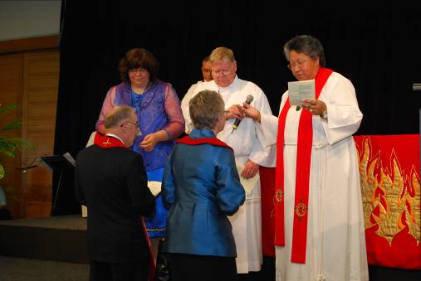

The induction of the new President, Rev. Desmond Cooper, and the vice-president, Mrs. Sue Spindler, by the outgoing President and Vice President, Rev. Alan Upson and Ms. Lana Lazarus, and Rev. Diana Tana, Tumuaki of Te Taha Maori.

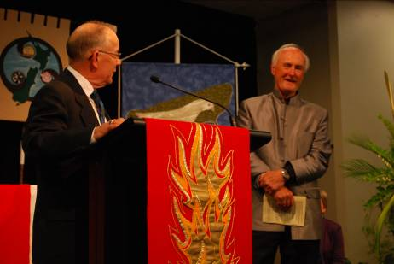

The new President, Rev. Desmond Cooper, acknowledging the Ex Vice president, Mr. Ron Gibson, at the conclusion of his term of office.

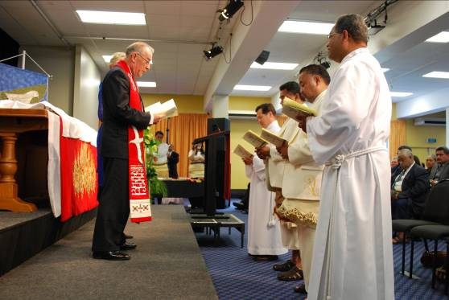

The ordination service. At right, Rev. Metuisela Tafuna,
formerly of Dunedin.

