
Dunedin Methodist Parish
Finding good in everyone Finding God in everyone
www.dunedinmethodist.org.nz

Presbyters: | Rev. Stuart & Rev. Cornelia Grant | 453 6762
Parish Stewards: | Dr George Davis | 453 6540
 | Dr Richard Cannon | 477 5030
 | Mrs Fay Richardson | 489 5485
Tongan Steward: | Mr Palanite Taungapeau | 456 3144
Parish Office: | Stuart: parish@dmm.org.nz  Cornelia: scch.grant@xtra.co.nz  Sarah: sarahc@dmm.org.nz | 466 4600
PARISH BULLETIN
28th November 2010

WORSHIP FOR SUNDAY 5th DECEMBER 2010
9.30am |  | Mornington | S Grant
9.30 am |  | Mosgiel | C Grant
11.00 am |  | Glenaven | S Grant
11.00 am |  | Wesley | C Grant
1.00pm |  | St Kilda | Comb. Wesley
6.00pm |  | Broad Bay | S & C Grant

PRAYER FOR THE FIRST SUNDAY IN ADVENT
We long for the fullness of your peace and justice in our midst, O God.
Help us to be alert to signs that your reign is breaking into our lives.
Strengthen us to do our part in bringing your promises to life in our waiting world. Amen.

CHRISTIAN WORLD SERVICE – 65th Christmas Appeal
On this first Sunday in Advent you are receiving with this bulletin a donation envelope for this year’s Christmas Appeal. CWS gives thanks for the generosity of so may people in churches around the country who have given generously in the past, both to the Christmas Appeal and to the various special appeals which have been occasioned by disasters like the Haiti earthquake or the Pakistan floods. Please give to the present appeal generously. The needs are great, and you can be assured that your gift will be well used.

MEETINGS
Mornington Leaders’ Meeting. 7.30pm, Tuesday 30 November.
Property, Finance and Resourcing Committee, 7.30pm, Thursday 2 December.

WESLEY MWF
Final meeting for 2010 will be held at St Barnabas Rest Home on Thursday 2nd December at 12.30. Please come and share Christmas lunch with us, bring a friend. All welcome. Let Ivy or Joyce know if you will be there by 28th November.

MARY’S RETIREMENT PARTY: INVITATION
To help celebrate my retirement from university, my Mornington friends are cordially invited to join the party on Sunday 5th December at Mary and Sue’s place, 197 Balmacewen Road anytime between 2 pm and 6 pm. Afternoon tea refreshments will be on the go all afternoon, so please come and go whenever it suits you. Instead of presents we thought it might be fun to see how many goats we can buy for Ugandan families via CWS, so feel free to contribute towards that to mark the occasion if you wish.


DISTRICT METHODIST WOMEN’S FELLOWSHIP
AFTERNOON TEA PARTY

Saturday 4th December 2010
Mornington Church Hall, 2.00pm

Gloves to be worn, also gloves for display.
A story or two to be told.
One plate per car load, please.
Tickets $5.00 available from MWF members.
Anyone who can provide or needs transport phone Sally – 4544489

PARISH FAREWELL FOR STUART AND CORNELIA
There will be an afternoon tea at Mornington Church at 3.00 pm on Sunday 19 December at which the Parish will farewell Cornelia and Stuart. The afternoon tea will be preceded by a walk through the town belt to Mornington Church for those who want to participate. The afternoon tea will also include a short concert. More details will follow.

This year, I am representing the Methodist Mission in working alongside the Dunedin food banks so food parcels can be provided to those people who will find it difficult to put a festive meal on the table at Christmas.

While the agencies are able to provide the basis of the meal we are hoping to also include some treats that can give each parcel a festive flavour. To help us do this we are asking members of the congregation if they would like to contribute something to a parcel.

To help give you an idea of the sorts of things that would be helpful I can suggest some examples:
Chocolate biscuits, Confectionery, Shortbread, Truffles, Candy Canes, Balloons, Christmas Crackers, Christmas Cake, Jelly, Meringues.

Your donation can be left in the box in the Church entrance.

Thank you, Shona Johnsen, The Methodist Mission.

WHAT WOULD JOHN WESLEY SAY? (from Laura Black’s report to Parish Council)
Rev Greg Hughson and I are keen to create a local Methodist Public Questions Forum – a ginger group focussed on practical engagement with public issues. Something informal, meeting once a month or so at someone’s house over a cuppa, to tease out debate, form ideas, and rev us up! We’re planning the first forum for the end of January – please email laurab@dmm.org.nz or phone me on 466 3026 if you are interested (or you want to volunteer someone who should be interested!!).

WANTED!
Whole households of good used furniture, hundreds of plants, books, clothes, garden tools, and shelf-loads of preserves, jams and BAKING for the day. What Day? The Day of the Great Mission Jumble Sale to be held on Saturday 26th February, on behalf of the Wesley Village Project.
Please ring Sarah (466 4600) to arrange for their collection or they can be delivered to Wesley House, 15 Wesley Street, at the end of a drive-in. All items welcome: we want a hall filled to overflowing! Throw out that old sofa and chairs, make a pack of jams, look up those delicious recipes, empty the bookshelves and turn on the cake-mix mixers!

HAPPY BIRTHDAY to the following children:
- 29th November – Lachlan Jones
- 3rd December – Ryan Elkins

PARISH ROLL UPDATE
Many thanks to all who have returned the forms that were sent out some weeks ago regarding the update of the parish membership rolls.
If you have not sent yours in yet, it would be helpful if you would do so in the next few days. If you have not received a form, there are some available at church today, or for those on e-mail, Stuart could send you one.

FINANCIAL REPORT FOR JULY – SEPTEMBER
Income Expenses
Offerings Ministry 23,907.74
Broad Bay 530.00 Ministry Rental 4,420.00
Glenaven 1,247.19 Removal Fund 720.99
Mornington 13,245.60 Connexional Budget 1,800.00
Mosgiel 4,213.90 District Expenses 624.99
Wesley 2,681.60 Conference Expenses 790.13
Glenaven Property 2,505.00 Property Expenses 1,185.96
Rental Income 6,263.89 Other Expenses 3,197.72
Other Income 370.07 Bank Fees 1.51
_______ _______
31,057.25 36,649.04

The results for the first quarter for 2010/2011 are above. While showing a loss, results are much as expected. There are a number of one off expenses that occur in the first quarter; ACC, educational material for congregations and Sunday school and Conference expenses being examples.
If you would like a full copy of the first quarter please contact the Parish Treasurer, Lynley Kloogh 4536978.

PHOTO’S FROM MOSGIEL 125th ANNIVERSARY CELEBRATIONS:
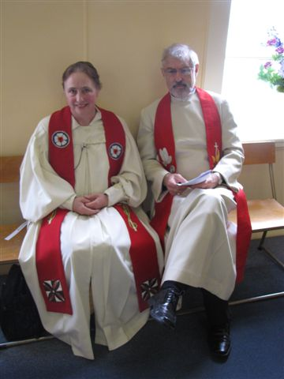
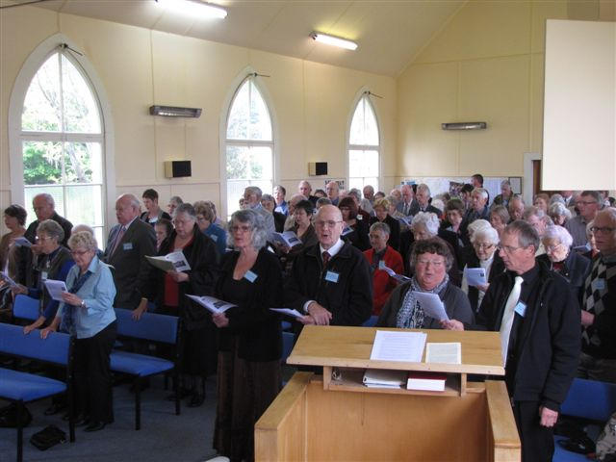

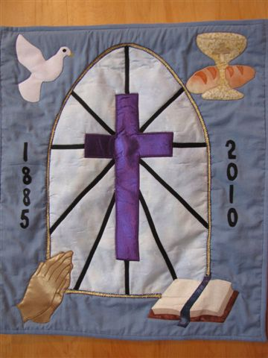
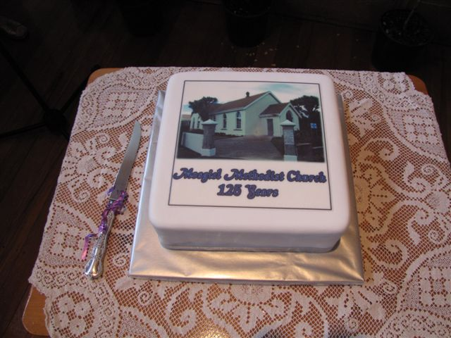

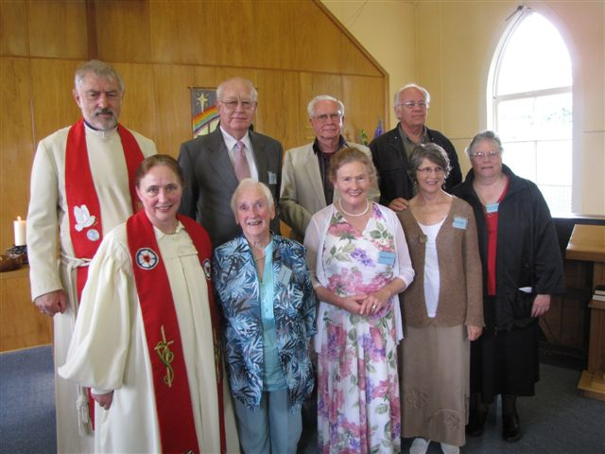
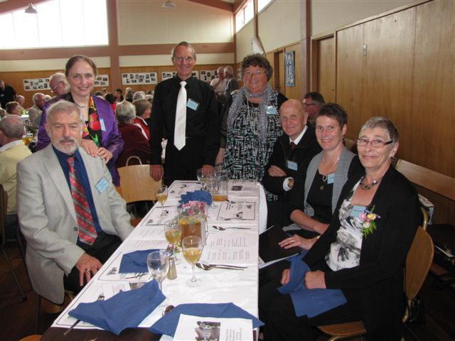



NAME CALLING

It was not until Wednesday of this week that, for me, the reality of the mining disaster really struck home. Up till that time we knew the number of the men missing deep in the mine, and while some of them had been identified, others were not.

Various reasons for this were given, and that of personal privacy was clearly a paramount concern for the police. I understand they felt they could not release all the names until they had the permission of the various families, and since some of these were from overseas, getting that permission would take time. Probably the police were correct in acting in this way, but it left those of us watching and waiting on the side-lines with a feeling of frustration. In fact, the whole of the last week has been a time of agonising frustration for those most affected by the tragedy.

But on Thursday morning our newspaper had all 29 photographs and names. Quite suddenly these people became real, though at the very time when hope for their recovery vanished. We looked at them, and somehow they and we came together in the same world. That remarkably brave man, Peter Whittall, the mine manager, had tried to help us understand the human side of mining – now it was made just a little easier by getting to know each one of them as an individual person. All along, however, he knew them, and it was that intense personal bond that sustained his slim (I guess) hope that they might be saved.

Peter Whittall has taught us all a lesson in caring.

Names are a treasure. They are our most precious personal possession. We may, of course, share a name with others, but there is only one of us. We may not like the name we were given as a child, and some will choose to re-identify themselves when they become adults. Then the name they choose becomes an even more powerful symbol of who they are. Our names are our history and our passport to the future.

But what about the name of God? In the Judæo-Christian tradition we are uneasy with the notion that God has a name that we can know and use. The story of wrestling Jacob encapsulates that whole idea that to know the name of another gives you power over them. Jacob did not prevail, and, strictly speaking, we cannot ever claim to have that knowledge of the Creator. The nearest we come is when God refers to God as “I am.” And that is why, at this Advent time, we have to ‘wrestle’ again with the name given Jesus by the angel – he is ‘Emmanuel’, he is ‘God with us’. What greater thing can be said about the child of Bethlehem, the travelling preacher from Galilee, the dying visionary hanging on a cross, than that this man is ‘God with us.’

It is, of course, so much easier for us because the parents of the child gave him a perfectly ordinary name, Jesus. The folk from Nazareth would have been called Jesus bar Joseph – Jesus son of Joseph. Without such a normal name how could we talk about the man we believe to be the world’s saviour. But let’s not forget that this quite ordinary name is only part of the story – Jesus is ‘God with us’.

And as we grieve for, and pray for, 29 men, and their families and loved ones, let us give each one of them the name that belongs to him. In that way they each become part of us.

Donald Phillipps


Frequently Asked Questions:

How is my donation used?
The appeal features the work of our partners whom CWS supports overseas; four of the current 30 partners working in community development programmes and disaster relief. CWS also funds campaigns against the causes of poverty, and educates New Zealanders about global aid, development and justice.

In the 2009-2010 year 82% of expenditure went to international partner programmes; 5% of expenditure went to youth education and advocacy campaigns within New Zealand; 6% expenditure went on marketing and fundraising and 7% on administration and overheads.

How can I be sure my money gets to those who really need it?
CWS has 65 years of reliable and trusted relationship building with overseas partners. For humanitarian relief and development work, CWS gets money to its partners quickly. When disaster strikes where we have no local partner, CWS can get money to that country through the ACT Alliance, (Action by Churches Together). This is the worldwide alliance of 100 churches and church-related organisations that work together in humanitarian assistance and development. Throughout our history we have been entrusted with generous sums from the New Zealand Government’s official development assistance fund, and have been regularly reviewed, with positive reports of our effective work. The last report commended our long commitment to reducing poverty and our excellent financial management.

