
Methodist Parish
Finding good in everyone Finding God in everyone
www.dunedinmethodist.org.nz

Presbyter: | Rev. Siosifa Pole | 455 2923
Parish Stewards: | Dr George Davis | 453 6540
 | Dr Richard Cannon | 477 5030
 | Mrs Fay Richardson | 489 5485
Tongan Steward: | Mr Palanite Taungapeau | 456 3144
Parish Office: | Siosifa: parish@dmm.org.nz  Sarah: sarahc@dmm.org.nz | 466 4600

PARISH BULLETIN
27 February 2011

WORSHIP FOR SUNDAY 6th MARCH 2011
9.30am |  | Mornington | TBA
9.30 am |  | Mosgiel | TBA
11.00 am |  | Glenaven | TBA
11.00 am |  | Wesley | TBA
1.00pm |  | St Kilda | TBA
6.00pm |  | Broad Bay | TBA

For members of the parish, we are in a time of mourning because of the earthquake that devastating the people of Christchurch. We are deeply affected in many levels because of this horrendous tragedy. We send our condolences and sympathy to all those who are affected in this catastrophic event. Please continue to pray for them and offer help in whatever way that necessary for those who are in needs. I have given my approval to Ken Russell to contact people within the parish who could offer shelter in their homes if there will be a request from the Connectional office. I am still waiting for the District Superintendents if there will be a co-operate assistant that we as a District could offer together to the people of Christchurch.

PRAYER VIGIL
A request from the Parish Superintendent for all the congregations in the Dunedin Parish for a Prayer Vigil for the people of Christchurch at Mornington Methodist Church between 5pm till 8pm on Sunday. People can come whenever is suit them to pray for those who have lost loved ones, the volunteers, the rescue people, the Prime Minister, the government, the Connexion, the local churches and communities.

EXPLORERS GROUP - First meeting of the year, will be held Sunday 27th February, 4.30pm in the Mornington Church Lounge. Everyone welcome.

MORNINGTON WORLD DAY OF PRAYER
This year's Mornington World Day of Prayer Service will be held in the St Francis Xavier Church, Benhar St on Friday 4 March at 7.30pm. The Speaker will be Father Cyprian from St Francis Xavier Church. The service has been prepared by the women of Chile. Women, men and young people are invited to join in ecumenical worship and fellowship.

WORLD DAY OF PRAYER – MOSGIEL
World Day of Prayer Ecumenical Service Friday 4th March 2011 1p.m. {please note change of time} at The Salvation Army 4 Lanark Street, Mosgiel. This years service was written by the Ladies of Chile. All very welcome.

RAISE IT UP – TAIERI YOUTH SHOWCASE
Thursday 3rd March, 7.30pm, Coronation Hall, Mosgiel. A Festival of the Plain event. Support our young people. An evening of fun and entertainment. Join celebrity judges in choosing our top talent. Tickets available at Mosgiel Christian Bookshoop. Adult $5, Children under 12 $2, Family Concession.

CHILDREN’S DAY
6th March, Nairn Street Reserve, 10.30am – 3.00pm. Worship Service – 10.30, stalls open at 11.15. Bring your picnic lunch and join us in the park! All the fun of the fair; food stalls, games, bouncy castle, mini cars, face painting, demos, crafts, Sport Otago and Classic Hits “Callum & P”.

SOCIAL JUSTICE GATHERING
Join us and Share Your Concerns, Your Ideas, and (Possibly) Look to Action
Are you concerned for the future of our young people? Does the growing gap between rich and poor offend you? Do you want more done for environmental and economic sustainability? Do you want more compassion and love in Government decision-making? Would you like to learn more about public policy issues, but don’t know where to start?
Greg Hughson and Laura Black are hosting the inaugural (we hope!) Dunedin Methodist Public Questions Forum on Sunday 6th March from 3.00 pm - 4.30 pm at Laura’s House (29 Marewa Street in Kew). Bring a small plate, coffee and tea will be provided.
Please note: this is NOT a committee – there will be no minutes or decisions; just good conversation, fellowship, and support for an active Methodist public theology.
RSVP to Laura on 466 3026 or laurab@dmm.org.nz by Wednesday 2nd March.

ANNUAL OTAGO HOSPITAL CHAPLIANCY TRUST STREET APPEAL
On Friday the 18th of March the Hospital Chaplaincy Trust will be holding it's annual street appeal. If anyone is available to give an hour of their time to assist as a collector it would be most appreciated. Both in-door (the Meridian Mall) and street corner collectors are needed (for those of you that might have a preference). The Hospital Chaplains do a very important job, providing comfort and support to our community, often at times when they are at their greatest need.
If you can help please call Greg Jones (evenings: 473 8373) or e-mail greg.jones@otago.ac.nz. Alternatively, members of the Mornington congregation might like to see me at church.
Many thanks. Greg

TRANSFORMING SESSIONS AND PARISH COUNCILS INTO COMMUNITIES OF SPIRITUAL LEADERS
A seminar led by Dr. Charles (Chuck) Olsen. When: Thursday 24 March 2011, from 3:30 to 5 p.m. Where: Knox Centre for Ministry and Leadership. All welcome. No charge.

BIBLE STUDY (CELL) GROUP.
Geoff Preston is willing to lead a weekly Bible Study Group for anyone interested. A list will be available in the Foyer after the Service.
Kindly enter your name and Telephone number, as well as your preferred day of the week, morning, afternoon, evening(Monday to Thursday.)
This notice will run for three Sundays, after which a get together will be arranged to decide further details.

STEADY AS YOU GO
This is a group which does gentle exercises which have been put together by Age Concern as a falls prevention programme. It meets each Wednesday from 1 to 2pm at the Mornington Methodist Church. For further information please ring Brian or Margaret Connor at 488 4345

AMANA CHRISTIAN SCHOOL 10th ANNIVERSARY INVITATION
Friday, March 4th 6pm: Bring and Share meal at Amana 80 Gordon Rd. Worship time 7.30pm. Saturday, March 5th 4pm: View Early Learning Centre and Light and Hope Conference Centre. 14 Gordon Rd. 5pm Sausage Sizzle $2, Muffins $1 or BYO 6pm Auction to raise funds. Great Bargains. RSVP to PO Box 13, Mosgiel or email: amana.school@ihug.co.nz

HIGHLIGHTS FROM PARISH COUNCIL MEETING 16 FEBRUARY 2011
- Parish finances: income from the congregations for the last quarter was above budget (well done everyone!), but we still have a year-to-date deficit of -$8,385 due to higher than expected conference expenses and lower than expected rental income from the Queens Drive and Tedder Street properties.
- We now have new tenants in both the Queens Drive and Tedder Street houses, and hope for better rental income from these properties henceforth.
- The Mission Resourcing unit of the Methodist Church is still processing applications for the half-time ministry position in the Dunedin Parish. They have indicated, however, that there are two applicants that may be suitable and at least four applicants from overseas who are not suitable.
- The Parish Stewards will meet with Siosifa to draw up a Preaching Plan for the Parish for the period March – May 2011.
- The Otago-Southland Synod meets 25-27 March in Queenstown followed by the School of Theology, 27-30 March, also in Queenstown.
- Parish Council meetings for the remainder of 2011: 25 May (Mornington); 10 August (Wesley); and 23 November (Mosgiel).

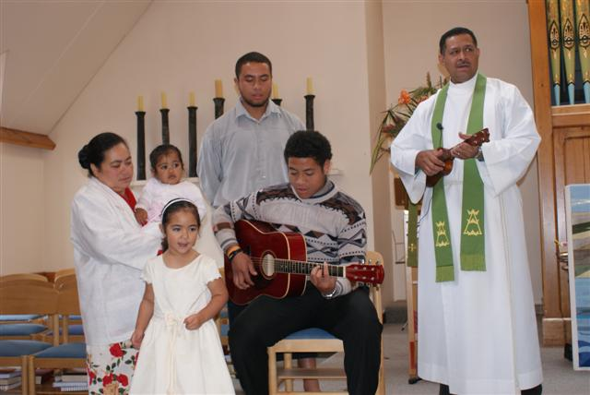
FAMILY WITNESS - Mornington congregation were delighted on Sunday 13th February, when Siosifa and Naomi and their family rose to sing a Tongan song "E 'Otua Pataki Au" (God Guide Us ). We are thankful for the special gifts the Pole family brings to the Parish.

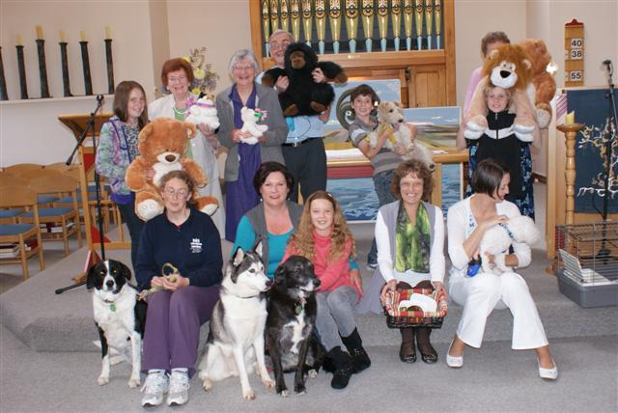
PETS SERVICE at Mornington. A very successful service was held last Sunday. Dogs were the favourite pet, by far, and so well behave all of them. Most "doubtful" was a pet rat, caged, but he/she was quiet and respectful. The stick insect stayed away this year. Stuffed toys were welcome, and added to the variety. Not quite Noah's Ark, but not far away. Thanks to Colin Gibson for the time and thought he put into creating a memorable service. See the website, soon, for the script of a remarkable sermon.


Know-it-alls, opinionated, uppity, bee-in-the-bonnet, monomaniacal, obsessive, naysaying, doom and gloom, froth-at-the-mouth, fame hunting, pain in the rear, let it go already … writers of letters to the ODT!

Good grief! Do they really think that we want to read their self-involved, miss-the-trees-for-the-wood, dribbling day after day? Don’t they have anything better to do with their time?

You know, Mark Twain had it right, better to remain silent and be thought a fool than to speak out and remove all doubt!

Grump.

And yet … to stay quiet is to be seen to agree; it is said that silence is a fence around wisdom and that in the end, what is remembered is not the words of our enemies but the silence of our friends (Martin Luther King). Certainly, staying quiet is a pretty good way of ensuring that things stay as they are. To sin by silence when they should protest makes cowards of men said Abraham Lincoln, and he probably knew what he was talking about.

Methodists are in many ways and at many times called to make a difference. In doing so, we learn that some of the lives of others, of the life of our community and therefore of our shared lives, are deeply troubling. Our compassion for others inevitably leads us to indignation at their circumstances.

And rightly so. Yet indignation has its costs …

The fatigue caused by anger is one of the major causes of social worker burnout. Usually, the anger is held inside for far too long - all the hurt and frustration and disbelief piled up until there simply is no room to hold it all in any more, and it turns either outward or inward. Those who speak when all around them are silent nodders, can find the courage it takes to put their heads above the parapet equally draining.

Perhaps that is why those who do speak out often do so with such vehemence?

Unfortunately, the anger of the frustrated (in the pages of the ODT, on talkback radio, in passing conversations) is often so confrontational, so, well, so angry, that it feels impossible to engage with. Would we find it easier if the “lock em up and throw away the key” brigade could talk more openly about the anxiety of being vulnerable, and the hurt of their losses? Probably.

Could we stay in conversation longer with those who are suspicious and rejecting of migrants, if they spoke instead of their worries about neighbourhood changing around them, and wanting to still see their selves reflected in their community? Likely so.

And if those who demand nothing changes while nothing is good enough could instead admit that they don’t want to be left behind, would it be easier to sit and chat? Almost certainly.

The good news is that there is a way through all this, and it lies in starting conversations in our community earlier; having the insight to raise issues before anger cements; and in broaching issues when compassion and empathy are still possible.

It lies in asking those who are the moderates to have the courage to speak first.

That would be us, then.

Laura Black

Christchurch Earthquake Prayer

God –the world is in an uproar.
While ordinary people in the Middle East
call for justice and a fair way of life,
the ground rolls beneath Christchurch again.

It's incongruous that I sit here looking out at green trees
and a still horizon beckoning me to hope
while troops are opening fire on demonstrators in Libya
and the Cathedral tower shatters.

Life is not fair - life is not just.
Nor is it able to be taken in measured doses.
Chaos can mean there is nowhere else to go
and nothing left to do
but to cry out to you
as though you are the silent ear,
hearing our cries
absorbing them into yourself
and crying with us.

Even as bullets fly and buildings disintegrate,
may compassion rise in all of us
to be the God who walks and talks in the world today.

By Sandy Ramage.

