
Dunedin Methodist Parish
Finding Good in everyone Finding God in everyone
www.dunedinmethodist.org.nz

Presbyter: | Rev. Siosifa Pole | 455 2923
Parish Stewards: | Dr George Davis | 453 6540
 | Dr Richard Cannon | 477 5030
 | Mrs Hilda Hughson | 487 6226
Tongan Steward: | Mr Kaufusi Pole | 455 0096
Parish Office: | Siosifa: parish@dmm.org.nz  Sarah: sarahc@dmm.org.nz | 466 4600
PARISH BULLETIN
6th May 2012

WORSHIP FOR SUNDAY 13 May 2012
9.30am |  | Mornington | K Russell
9.30 am |  | Mosgiel | S Pole
11.00 am |  | Glenaven | K Russell
11.00 am |  | Wesley | S Pole
1.00pm |  | St Kilda | TBA
6.00pm |  | Broad Bay | No Service

MOSGIEL BAPTISM
Today we welcome with love, Olivia Lee daughter of Julie & Barry Harwood who is to be baptised into the family of God in the Mosgiel Methodist Church. You are all welcome to stay after the service for morning tea.

PARISH COUNCIL MEETING
There will be a Parish Council Meeting at 7.30 pm on Wednesday 16 May at Mornington Church. Council members please check this date as it may differ from the provisional date you noted at the last meeting.

MOSGIEL MID WEEK SERVICE
Wednesday 9 May at 2pm. All welcome.


WESLEY LEADERS MEETING
To be held on the 15th of May at church at 10.30am.

MOSGIEL LEADERS MEETING
To be held on the 15th of May 7.30pm

MUSICAL SOCIETY CONCERT
1.30pm Sunday 13th May at Mornington Methodist Church. Programme; Amanda Cole singing Debussy, Brahms and others. Cost $2.00.

MARGARET MAHY IS COMING
Yes, on Wednesday, May 23, the famous Christchurch poet and children’s writer, is coming on a rare visit to Dunedin for the Parish Open Education programme. Be at Mornington Methodist Church, Galloway Street, at 7.30pm, to meet Margaret and share a concert of Margaret Mahy songs and stories. Admission $5, which covers a light supper. You are advised to come early.

There will be a special Judy Russell meal beforehand, starting at 6.00pm, at a cost of $20. Ring Judy (455 3727) or book at Mornington Church. Profits will go to the Water for Life Christian World Service project, and donations can be given at the door.

HAPPY BIRTHDAY
To the following children celebrating a Birthday:
6th May – Alicia Horsfall, Kirstie Kopi
10th May – Naomi Pole

CLINICAL PASTORAL EDUCATION (C.P.E.) OTAGO AND SOUTHLAND SPRING 2012
CPE is action/reflection learning from supervised ministry practice for greater pastoral understanding and competence. CPE is for ministers, priests, chaplains, theology students and lay persons engaged in ministry.
Fortnightly CPE seminars will meet Mondays 3.00 – 9.30pm, and Tuesdays 9.00am – 3.30pm. August 27th to November 20th 2012. Venue: Peter Mann House, 1a Shand Street, Green Island. Begin your application process now by contacting;
Rev. Mary Huie-Jolly, maryrhj@gmail.com, phone 001 404 790 8232
Rev. Alec Clark, Anglican Diocesan Ministry Education Dunedin, 03 488 0829.

Story from the Mission

Towards the end of our Mornington school Wise-Up group, a young boy, Jack came and sat next to one of the facilitators. He whispered "Emily is talking in front of the class just like me." This was marvellous, because Emily, a very slight, silent and watchful child, scarcely spoke, and when she did she spoke so quietly she couldn’t be heard. Emily is still a very quiet child, she is still cautious, but she at the end of six sessions she was able to speak up in her peer group. Over the time we worked with Emily we discovered she was able to display her courage in other areas of the programme. She was one of the first volunteers to ‘dodge the shinai sword’, an exercise which has even the strongest children, a little uncertain. The sword is large, made of strong bamboo and makes a satisfying ‘thwack’ on the ground, before it’s swung in to a 180 degree arc, back and forth and back again. Emily dodged it with ease. She was fearless in the high-energy ball games and competed strongly in the games of tag. Jack’s sensitivity to Emily’s achievement in our was group commendable. He had noticed a big difference in his shy friend Chloe and in doing so he showed an equally big shift in his own learning. Seth, who came to us as sad and inward looking young boy focused on his own fears, was now able to notice and care about others.

WELCOME BACK!
Two highly regarded member of Y@M have come back from student experiences overseas - Vince Neaves (Sweden for a year) and Elisha Gordon ( France for three months).
Vince and Elisha met with a goodly crowd of Mornington folk, including many of Y@M, on a recent Tuesday night to “report” on their experiences. This they did with no hint of nervousness, but spoke with articulation humour about student life in two widely contrasting countries. It was obvious to everyone present what a broadening and maturing experience these two fine young adults have had - and both left no doubt they had left many good friends to whom they would like to return.
Picture shows Elisha and Vince, Vince with his blazer adorned with a large collection of badges exchanged with other visiting students and rotary clubs.

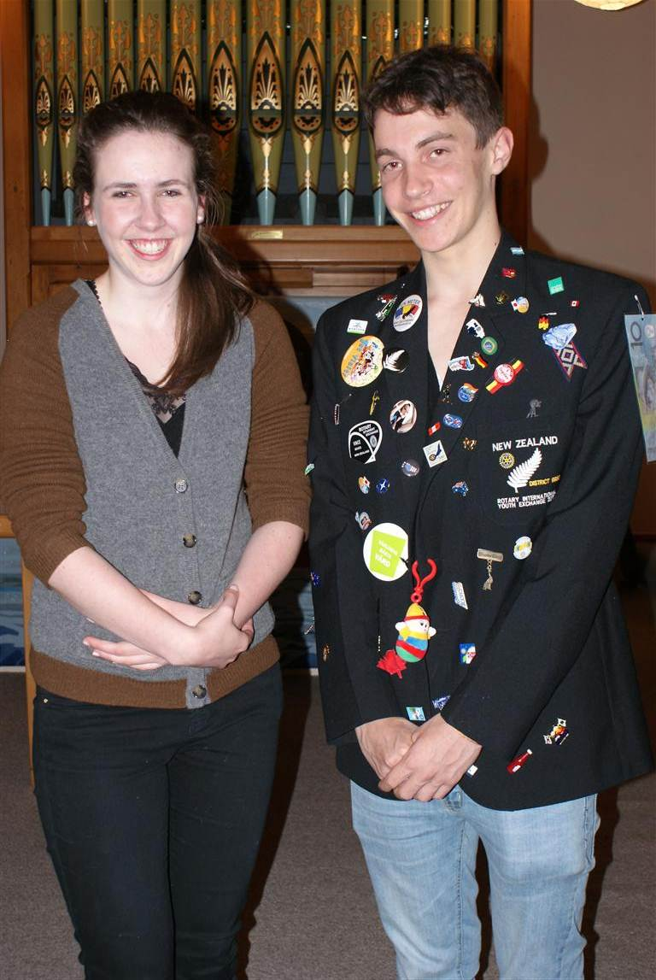



It was the great bard himself who extolled the quality of mercy as being among the highest of human values. The quality of mercy is not strain'd, it droppeth as the gentle rain from heaven upon the place beneath: it is twice blest; It blesseth him that gives and him that takes . . . . .

But one looks in vain for even a skerrick of mercy, even a drop of the gentle rain of human kindness in the government's announcement that it will change the immigration laws in such a way as to "deter people smugglers" and deal with the problem of "queue- jumping" asylum seekers. New Zealand will not allow itself to become a "soft touch" for these people, says the PM.

The new rules will apply to those who arrive in groups of 11 or more, and while there were no current plans to build detention centres such as Australia, it seems that early planning envisages the Devonport Naval Base as a likely place where detainees will be processed. The changes would mean boat people who arrive illegally, but are subsequently accepted as bona fides refugees, would be treated less favourably than those accepted into New Zealand through the usual UNHCR process. In short, under the amended law, boat people

* will be detained under a group warrant, rather than individual warrants.
* if accepted as refugees, will not get residency for at least three years after their refugee status is reviewed.
* will only be able to sponsor immediate family members to NZ, but not extended family such as adult siblings or parents.

So is this move the good thinking that has been welcomed in some quarters, or rather, a mean-spirited paranoia in the face of one of the more tragic human situations of our time?

Very much the latter, I'm thinking. The nearest that any boat-load of "illegals" has ever come to reaching these shores is the northern tip of Queensland - a group of Chinese Falun Gong members fleeing a regime committed to their extermination. Although their boat was deemed seaworthy, the families reluctantly accepted advice that indefinite detention in Australia was a better choice than likely disaster and death in the turbulent waters of the Tasman. This, says Mr Key, was a "close call." Repeatedly he refers to a "mass arrival" that would threaten New Zealand's security.

The Government admits it is addressing a 'potential' threat, and nothing that so far has looked in any way likely of realisation. Yet even so, Mr Key said officials from 17 different government agencies would begin an 8-week exercise this week to practice for such a situation, a simulated mass arrival called Operation Barrier. And this at a time when the Govt is prescribing austerity for itself, and the rest of us!

Almost everything about this immigration scare-mongering raises my heckles. Deputy Director of Amnesty, Rebecca Emery, is correct. They're "using a sledgehammer approach to a non-existent problem." Such people, she says, were they to eventually succeed in reaching our shores, should not be termed as queue jumpers. Such is the urgency of every legitimate asylum seeker's situation, that talk of an orderly queue, each one patiently waiting his/her rightful turn, is totally inappropriate.

While I have no more time than the Prime Minister for people- smugglers, all the rhetoric from him and Immigration Minister Nathan Guy, raises the spectre of a nation consumed by xenophobic fears. The place for dealing with the wicked trade of people smuggling is at the point of origin. The focus for this country should be their pitiful human cargo, desperate people who will give all they have in this world to escape with their lives from tyrannous regimes. And should we need to say it - they too are of the human family, bone of our bone and flesh of our flesh, who only by the accident of birth were born into nations of acute oppression. They too deserve a place under the sun. Is their "crime" or "sin" to seek asylum in a country under-populated by world standards and possessed of the rich panoply of freedoms for which these people crave? And are the desperate measures to which these boat people are prepared to resort to escape their living hell such as to warrant the current paroxysm of fear and loathing for the "threat" they pose to us?

Let's be clear about this. New Zealand in recent years has consistently fallen behind in accepting its quota of 750 "legal" refugees under its UNHCR obligations. In so doing it has copped a lot of flack from humanitarian agencies detecting a growing reluctance to put money and hospitality behind the liberal-sounding rhetoric for which we like to be known in the international community. And inevitably, the latest measures, if enacted, will confirm in no uncertain manner the inward-turning of our national psyche, a psyche suspicious of strangers and selfishly protective of who we are and what we have.

I am ashamed of that. Have we forgotten the essential reality of our nation, that we were all boat people once? Indeed, there is possibly no other place on Planet Earth more recently populated by boat people of one kind or another? Virtually all our ancestors came to these islands by boat - Maori, European, Pacifica, Asian. In more recent times those boats had wings, and took hours to cover the distance that earlier took weeks, even months, by steamer, sailing ship, and canoe. But a boat people we are, whose boats were peopled by men women and children of urgent and sometimes desperate agenda.

Shakespeare's Portia does well to remind us of the essential human quality of mercy. When at our most vulnerable before the enforcers of power and authority, when we have spent all we have to grasp one opportunity of a better life and have nothing left to plead but our own desperate circumstances, our only remaining hope is that as strangers at another nation's door we will be greeted with mercy, not suspicion; with compassion, not hostility.

Mr Key - don't make our nation a fortress. Open our doors as they have been opened before. Take stock of mercy, that loveliest of virtues, which blesses him that gives and him that takes.
Ken Russell

We are the branches and Christ is the vine

