
Dunedin Methodist Parish
Finding Good in everyone Finding God in everyone
www.dunedinmethodist.org.nz

Presbyter: | Rev. Siosifa Pole | 455 2923
Parish Stewards: | Dr George Davis | 453 6540
 | Dr Richard Cannon | 477 5030
 | Mrs Hilda Hughson | 487 6226
Tongan Steward: | Mr Kaufusi Pole | 455 0096
Parish Office: | Siosifa: parish@dmm.org.nz  Sarah: sarahc@dmm.org.nz | 466 4600

PARISH BULLETIN
20th May 2012

WORSHIP FOR SUNDAY 27 May 2012
9.30am |  | Mornington | S Pole
9.30 am |  | Mosgiel | G Watson
11.00 am |  | Glenaven | S Pole
11.00 am |  | Wesley | G Watson
1.00pm |  | St Kilda | TBA
6.00pm |  | Broad Bay | No Service


BROAD BAY
Service times are 4.00pm during the winter months.

EXPLORERS GROUP - Meets Sunday 27th May at 4-30pm in the Mornington Church Lounge. All welcome.

MORNINGTON WOMEN'S FELLOWSHIP
The next meeting of Mornington Women's Fellowship will take place on the 30th May (please note the change of date), at Rata Lodge at 7.30 p.m. Rata Lodge is at 350 South Road (the old Methodist Church Hall).
The Guest Speaker will be Mrs Andrea Mosley.

MARGARET MAHY CELEBRATION
Margaret Mahy has suffered a serious accident, and will not now be able to come to Dunedin to share in the Open Education programme in her honour. However, a full programme of music and story readings will continue and her internationally famous illustrator and children’s writer David Eliott will talk about his work with this great New Zealand poet. So come to Mornington Methodist Church, Galloway Street, on Wednesday 23rd May at 7.30pm, to enjoy a sparkling concert of Margaret Mahy songs and stories. Admission $5, which covers a light supper.

There will be a special Judy Russell meal beforehand, starting at 6.00pm,
at a cost of $20. Ring Judy (455 3727) or book at Mornington Church.
Proceeds will go to the Water for Life Christian World Service project, and
donations can be given at the door. There will also be a ‘silent’ auction of one or more books autographed by Margaret Mahy and David Elliot.

HAPPY BIRTHDAY
To the following children celebrating a Birthday:
- 21st May – David Cannon

Story from the Mission
I When assessing this man who lives in isolation of family and friends I enquired about how he cares for himself in relation to meals, the conversation progressed to where he told me that he didn’t bother much with drinking as getting up and down from his sofa to make himself a cup of tea was too much of a hassle because he has for years experienced back pain. A number of years earlier he had been assessed as not being eligible for equipment funding and because he couldn’t afford to purchase the equipment himself he just tolerated the situation. When I suggested the Blokes Shed may be able to help he was very interested. Within days the Blokes’ Shed set to making him leg raisers for his sofa. When I visited last week he couldn’t stop telling me what difference the raisers had made and yet he had tolerated this situation for years. As this man experiences depression he had become conditioned into accepting pain as a normal part of his life, but with some prompting he was motivated to find a simple solution to improve his wellbeing. Needless to say he is enjoying more cups of tea!

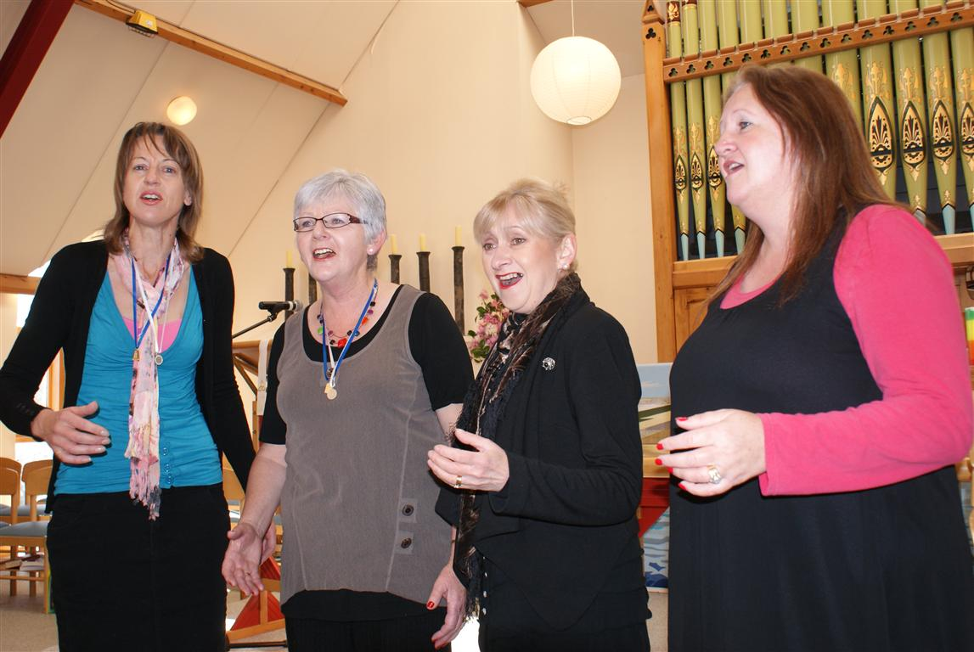
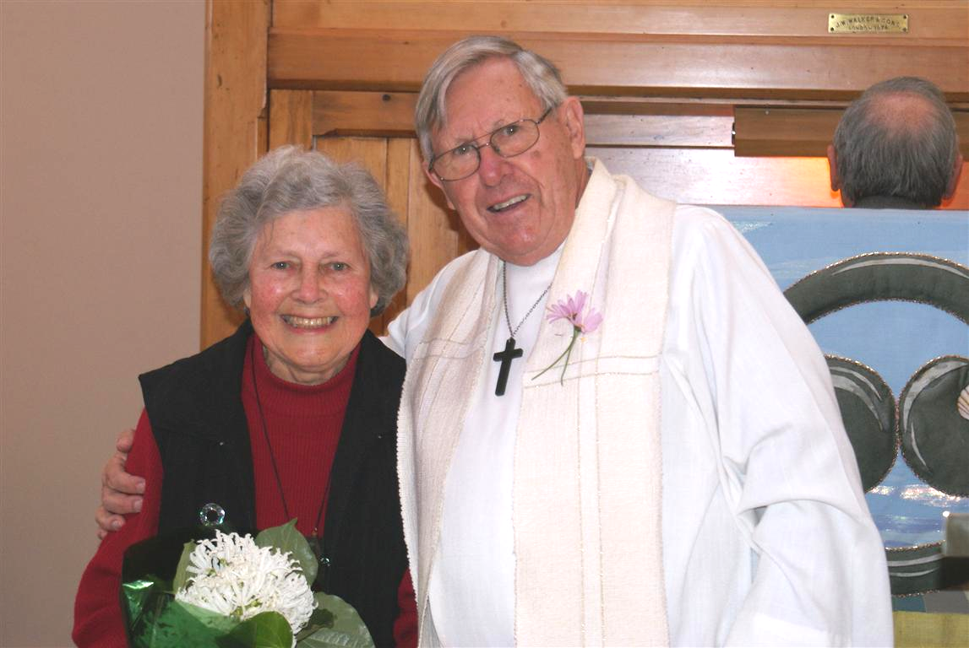
THE MOTHERS DAY SERVICE at Mornington had its fair share of warm fuzzies on Sunday. After a good deal of confusion it was agreed that of all the mothers present, MARGARET WOOD had been a mother for the longest time, for which Ken Russell presented her with flowers. As well Robyn Abernethy’s Sweet Adeline Quartet, including Robyn, Gloria, Wendy and Stella gave a beautiful presentation of an Irish Lullaby, which won very warm applause.



All the World's a Stage

It's great to hear of the many languages and cultures being represented at London's Globe Theatre right now, in a series of translated Shakespeare plays brought from all over the world and presented as a sort of artistic run-up to the Olympic Games.
In the old days, such an idea would have been greeted by bewilderment, even horror, that the Great Man could be translated into ANY language, even Pidgin! In the days of Empire, English/British culture was conveyed intact to the rest of the world and laid over whatever language and cultural practices were already in place -- if they were even known about. The same with theology, with the important difference that the New Testament -- unlike most of Shakespeare -- was progressively translated into multifarious native languages.
Since 1769, when a copy of Shakespeare's works sailed on Cook's Endeavour as part of Sydney Parkinson's library, Shakespeare has nevertheless exercised a lasting influence on the culture and language of this place. The plays were prominent in the school curriculum both when I received it and when I taught it; and the King James Bible, in the language of Shakespeare's time, was read to us all, whether we understood it or not. Doctrine, mostly formed over the first five Christian centuries, was perceived (like Shakespeare) as coming from above and from afar. Sermons and intercessory prayers -- at least in the Anglican church -- provided the only area in which the gospel's relevancy to us and our context might be (although it wasn't always) explored.
Things changed, however, through the 46 years I was in the church, and especially during the 20 years (1968-1988) I sort-of wasn't. There arose a whole raft of contextual theologies, formed in places far from Christianity's beginnings in the eastern Mediterranean (which means Middle Earth!), and not particularly related to our imperial mother-country. Our minister Rev Pole has in other Connections articles shown how strongly Pacific theology has been affected by Pacific contexts, languages and life.
Now we've had the wonderful turnaround, that Shakespeare's Troilus and Cressida, re-written in te reo by Te Haumihiata Mason, has been translated or re-located to London and performed at the modern version of Shakespeare's open-air theatre, the Globe.
Although the play's setting is the mythical war between the Greeks and the Trojans, Te Haumihiata Mason said in a Waka Huia interview that her goal was to set this production "firmly in the Maori world". Its classical subject, and Shakespeare's "classical" language, she said, called for the language of the ancestors, not the Maori that is spoken today. Like Rawiri Paratene, who acts the part of Nestor, she found deep similarities between te reo and Shakespeare's Elizabethan/Jacobean English: both are richly poetic and proverbial, and therefore complicated. "Every line was a challenge".
On the other hand, in the lives of the ancestors, European and Maori, "there was no technology and things were simple." When Shakespeare wrote this play, "there was only the sky, the land [and sea], man and woman, and animals. That was it. There were no distractions." That made translation "achieveable" -- with the aid of a computer!
The message of equality is the same as in the title of Anne Salmond's book Two Worlds, about first meetings between Maori and Europeans (1642-1772). The cultures each have their own integrity, but at base the play is about "the human condition", which she points out is the same for all, "regardless of your race or skin colour" -- and we might add, sex. It's a matter of pride that this great play was re-written by a Tuhoe woman, and taken to the world.

Helen Watson White

