
Dunedin Methodist Parish
Finding Good in everyone Finding God in everyone
www.dunedinmethodist.org.nz

Presbyter: | Rev. Siosifa Pole | 455 2923
Parish Stewards: | Dr George Davis | 453 6540
 | Dr Richard Cannon | 477 5030
 | Mrs Hilda Hughson | 487 6226
Tongan Steward: | Mr Kaufusi Pole | 455 0096
Parish Office: | Siosifa: parish@dmm.org.nz  Sarah: sarahc@dmm.org.nz | 466 4600
PARISH BULLETIN
24th June 2012

WORSHIP FOR SUNDAY 1st JULY 2012
9.30am |  | Mornington | S Pole
9.30 am |  | Mosgiel | D Phillipps
11.00 am |  | Glenaven | S Pole
11.00 am |  | Wesley | D Phillipps
1.00pm |  | St Kilda | Comb. Wesley
4.00pm |  | Broad Bay | S Pole

EXPLORERS GROUP
Meeting will be on Sunday June 24th, at 4-30pm in the Mornington Church Lounge. All interested people are very welcome to attend.


MORNINGTON METHODIST WOMEN'S FELLOWSHIP
The June Meeting will take place on the 27th June at 2p.m. This will take place in the Church Lounge, followed by the Devotions - taken by the Rev. Siosifa Pole, who will then chair the Annual Meeting. The Guest Speaker will be Siosifa - subject "Growing up in Tonga". All Welcome.

RADIO CHURCH
Shut-in folk, those who are unwell or those who cannot get to normal church services (or anyone else !) may tune in to:
Otago Access Radio 105.4 FM on Sunday mornings from 8.30 am – 9.00 am. A ministry of the Dunedin Inner City Ministers Association.

MESSAGE OF SYMPATHY
On behalf of the Mornington congregation and the whole of the Dunedin Methodist Parish, I would like to extend to Rona and the family our sympathy and condolences for the death of Rev Geoff Preston. Geoff died last Sunday, early in the morning. It is our Prayer that God’s peace and love will surround Rona and the family during their time of mourning and grieving.

MEMORIAL SERVICE FOR REV GEOFF PRESTON
A memorial service for Rev Geoff Preston will be held at Mornington Methodist Church on Monday the 25th of June at 2.30. There will be an afternoon tea after the service and everyone in the parish is invited to support Rona and the family on this service.

BIG THANK YOU
The Tongan Women Fellowship of St. Kilda would like to convey a big thank you to all those who attended their fundraising dinner last Friday evening. Your presence was really appreciated. It was really an expression of generosity and team work in our parish. We were able to raise $2,600 for our women projects on that evening. Once again, thank you for your love and support.

LAST WEEK’S FUNDRAISER BY THE ST KILDA TONGAN MWF was a huge success, and greatly enjoyed by all, including a very good representation from the rest of the Parish. A SUPERB MEAL was served and the Youth Group entertained. Members of the MWF proved themselves very enthusiastic dancers, none more so that Naomi Pole.
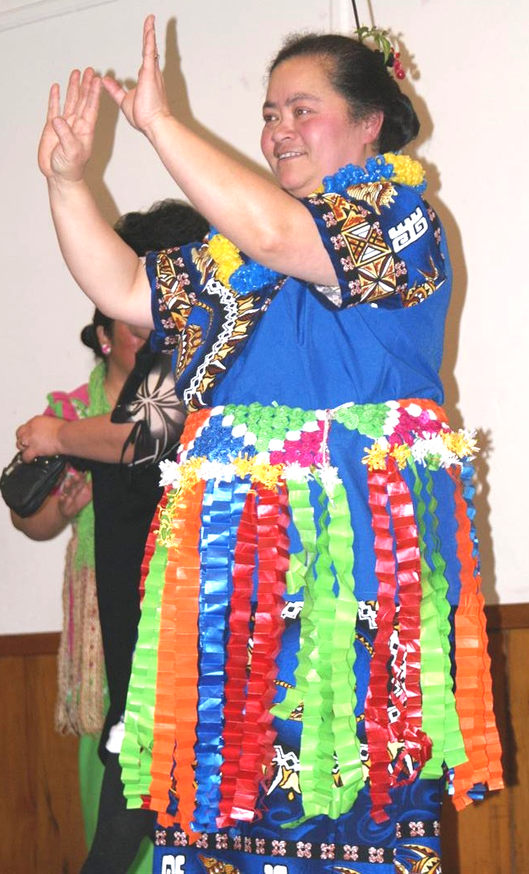
THANKS FOR A GREAT EVENING

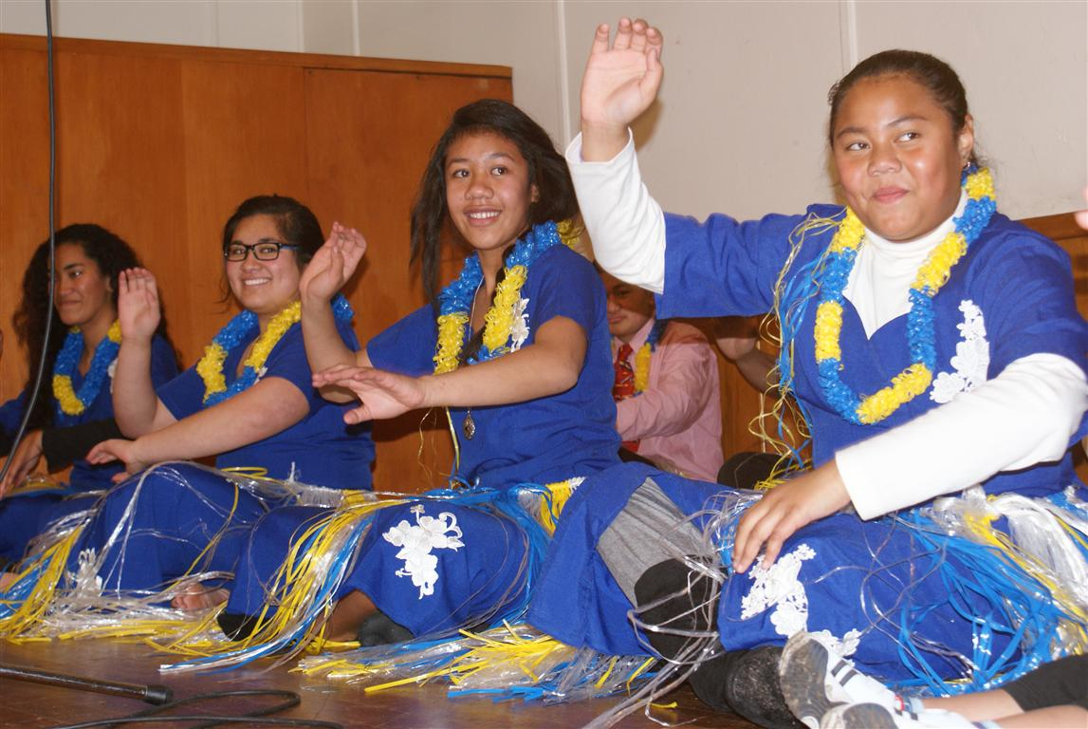

Story from the Mission
Currently on our Adults programme we have a really wide range of cultures – Chinese, Japanese, Turkish, Pacific Island. It is providing a really multi-cultural community. Many of our adult learners are extremely focussed and starting to work at the edges of our computer tutors knowledge. One new student came on board with us to learn Microsoft Project to apply for a specific job. This allows real peer learning and sharing with tutors and students. It allows a real sense of achievement for students.


The government has recently engaged in two important and contentious questions in the public sphere: the reproductive choices of beneficiaries and the ongoing childbearing of convicted child abusers.

Both of these topics have complex moral issues associated with them! The reproductive rights of beneficiaries touches on the personal right to manage one’s own body (which is a right to privacy), the nature of the social contract between society and the individual, the complex and contributory issues associated with poverty, and the very human right of free access to medical care (which was accidently acknowledged by the government as not being present for most beneficiaries).

The issue of ongoing childbearing of convicted child abusers of course raises the fundamental natural justice question of whether someone can be prejudged for actions not yet taken on the basis of past history. To what extent do we afford someone a second chance (after a bad bout of post-natal depression say) and to what extent are we willing to risk the health and welfare of a child to do that?

Yet this is not the landscape that either of these debates ranged through.

Instead these debates have largely been conducted via talk back radio – in actual fact, the debate on the childbearing rights of convicted child abusers was started by the Minister on Michael Law’s radio live programme.

Both left and right managed to ignore the voices of those they were talking about.

The actual policy change on beneficiary access to contraception – when it came – was so underfunded as to only reach 5% of the target population. And it turns out that Child Youth and Family already has the powers to remove children from parents likely to abuse again; and uses it well.

These, then, were not debates for the greater good, not designed to resolve complex moral and social issues, not started in order to make any kind of realistic change.

They were designed, I submit, to ginger up a portion of the population who respond to this kind of dog whistle politics. They were designed to categorise, dehumanise, and diminish another portion of the population who are a soft political target, without a voice of their own.

There is of course a considerable, short-term, political advantage for any government that kicks off this kind of media storm: they get a poll boost. They get to distract media attention from other issues, and they get to “own” the news cycle for another few hours.

However, there is a corrosive long-term effect that robs us all of some part of our humanity; that pushes our isolation from each other; that reduces the meaning and value and impact of being a society.

And that effect comes from our willingness to let go unchallenged the idea that other people can be talked about, rather than to, can be pushed and pulled and prodded and stripped of their dignity, that any/other people can be objectified for the sake of political advantage.

I remind you of Hannah Arendt’s description of the banality of evil, as I ask you to reflect upon the Edmund Burke’s belief that in order for evil to flourish, all that is required is for good men to do nothing.

The creep of these “little evils” into our public life as a nation should, and must, not stand unanswered.
Laura Black

